**IN THE CIRCUIT COURT OF SAINT LOUIS CITY**

**STATE OF MISSOURI**

|  |  |  |
| --- | --- | --- |
| CHRIS WHISTLER,  Plaintiff,  vs.  OAK GARDENS EARTH RESIDENCE,  Defendant. | )  )  )  )  )  )  ) ) ) | Civil Action No. 2019SMMT  JURY TRIAL DEMANDED |
|  |  |  |
|  |  |  |

**PETITION**

COMES NOW Plaintiff Chris Whistler, by and through the undersigned counsel, and for his/her cause of action against Defendant, alleges and states as follows:

**PARTIES**

1. Plaintiff Chris Whistler (“Plaintiff’) is a resident and citizen of St. Louis, Missouri who was employed by Defendant Oak Gardens Earth Residence (“Defendant”) or (“OGER”).

2. Defendant is and was at all times relevant to the allegations herein, a Missouri Corporation organized and doing business in the State of Missouri.

3. Defendant is an employer within the meaning of the Whistleblower’s Protection Act, R.S.Mo. Section 285.575.

4. At all times relevant herein, the individual actors named herein, including but not limited to Plaintiff’s supervisors and management-level employees of Defendant, were agents, servants and employees of Defendant and were at all times acting in the course and scope of their employment/agency relationship. Therefore, Defendant is liable for the actions of said persons.

**JURISDICTION AND VENUE**

5. The wrongful conduct alleged herein occurred in St. Louis City, Missouri, giving this Court jurisdiction over the Defendants and making this Court the appropriate forum for adjudication of Plaintiff’s claim.

**GENERAL ALLEGATIONS**

6. On or about January 3, 2017, Plaintiff was hired by Defendant as a cook.

7. Defendant is engaged in the business of operating a long-term care facility known as OGER.

8. During Plaintiff’s employment with Defendant, Plaintiff observed numerous unlawful acts and serious misconduct committed by Defendant through its agents, servants and employees.

9. Plaintiff observed that Defendant, through its Director of Nursing, Aubrey Mills, repeatedly brought his/her dog to work, where he/she ignored it and permitted the dog to enter the kitchen and dining room in violation of 19 CSR 30-87.030(1), (2), (3), (9) and (13).

10. Plaintiff observed evidence of urination and defecation by the Director of Nursing’s dog in the halls and dining room and notified his/her supervisor.

11. Plaintiff observed the dog enter the kitchen in violation of the regulations.

12. Plaintiff observed the dog create concerns about food sanitation.

13. Residents objected to the dog being in the dining room.

14. On June 10, 2019, the Plaintiff reported his/her concerns about the issues described in paragraphs 9-13 herein to Aubrey Mills.

15. On June 11, 2019, Plaintiff reported his/her concerns to the Missouri Department of Health and Senior Services.

16. On June 12, Plaintiff was discharged from his/her employment. Upon information and belief, Plaintiff’s termination was motivated by his/her reporting of Defendant’s unlawful acts and serious misconduct.

**COUNT I**

**Whistleblower’s Protection Act, R.S.Mo. Section 285.575 - Violation of Sanitation Regulations**

17. Plaintiff hereby incorporates by reference all of the preceding paragraphs of the Petition for Damages as if fully set forth herein.

18. The State of Missouri recognizes a public policy imposing a duty upon operators of long-term care facilities to ensure proper sanitation.

19. Plaintiff developed a reasonable, good-faith belief that Defendant, through its employees, agents, and/or servants, violated the sanitation regulations in a way that could materially affect the health and safety of residents, by failing to control a dog.

20. As a result of Plaintiff’s good faith belief that Defendant was in violation of State regulations, Plaintiff reported concerns to the administrator of Defendant, Aubrey Mills, and to Maize Arnold at the Missouri Department of Health and Senior Services.

21. Aubrey Mills and Maize Arnold are “proper authorities” within the meaning of R.S.Mo. Section 285.575(3).

22. Plaintiff was terminated on June 12, 2019, soon after reporting concerns.

23. Upon information and belief, Plaintiff’s termination was motivated by Plaintiff’s reporting of the serious misconduct by Defendant and/or the unlawful acts of Defendant described in this Count I to proper authorities, in violation of R.S.Mo. Section 285.575.

24. As a direct and proximate cause of Defendant’s termination of Plaintiff in violation of the Whistleblower’s Protection Act, the Plaintiff has incurred and will continue to incur lost income and benefits that he/she would have otherwise earned. Plaintiff is entitled to compensatory damages as a result.

WHEREFORE, Plaintiff prays for judgment in his/her favor and against Defendant on Count I of the Petition, for a finding that the Defendant’s termination of Plaintiffs employment violates R.S.Mo. Section 285.575, for an award of compensatory damages, for his/her reasonable attorney fees and costs expended, pre-judgment and post-judgment interest as provided by law, and for such other and further relief as the Court deems just and proper, including equitable relief to the fullest extent allowed by law.

CALL ME FIRST LAW FIRM

By: Call Me First

Call Me First

#1 Market Street

St. Louis, Missouri 63101

Telephone: (314) CAL-LNOW

Facsimile: (314) FACSNOW

CallMe@CallMeFirst.com

*Attorney for Plaintiff*

**IN THE CIRCUIT COURT OF SAINT LOUIS CITYq**

**STATE OF MISSOURI**

|  |  |  |
| --- | --- | --- |
| CHRIS WHISTLER,  Plaintiff,  vs.  OAK GARDENS EARTH RESIDENCE,  Defendant. | )  )  )  )  )  )  ) ) ) | Civil Action No. 2019SMMT  JURY TRIAL DEMANDED |
|  |  |  |
|  |  |  |

**STIPULATIONS**

Plaintiff Chris Whistler and Defendant Oak Gardens Earth Residence stipulate to the following:

(1) The signatures on Exhibit 2 belong to Aubrey Mills.

(2) Plaintiff drew Exhibit 1 while making his/her statement and both parties further agree that its contents are accurate and a smaller scale from the original.

(3) OGER is a long-term care facility as that term is used in Exhibit 7.

(4) Exhibit 9 is a copy of an email that originated from the email address assigned to Aubrey Mills at Olive Gardens.

(5) The parties agree that the only materials used to argue pre-trial motions are those provided in the case packet and the Rules of Evidence.

(6) Plaintiff is seeking solely backpay, and not seeking punitive damages, and any attorney’s fees will be determined by the judge in a separate hearing after trial (meaning not in this mock trial).

CALL ME FIRST LAW FIRM HELP IS ON THE

WAY LAW FIRM

By: Call Me First By: Help Today

Call Me First Help Today

#1 Market Street #2 Market Street

St. Louis, Missouri 63101 St. Louis, Missouri 63101 Telephone: (314) CAL-LNOW Telephone: (314) ASK-HELP

Facsimile: (314) FACSNOW Facsimile: (314) FAX-HELP

[CallMe@CallMeFirst.com](mailto:CallMe@CallMeFirst.com) HelpOnWay@helponway.com

*Attorney for Plaintiff Attorney for Defendant*

Jury Instruction 1

Verdict Directing--Wrongful Discharge in Violation of Public Policy (Whistleblower’s Protection Act)

Your verdict must be for plaintiff if you believe:

First, plaintiff is a protected person, meaning that plaintiff reported serious misconduct of the employer that violates a clear mandate of public policy as articulated in a constitutional provision, statute, or regulation promulgated under statute, and

Second, defendant discharged plaintiff, and

Third, such conduct of plaintiff as submitted in the First paragraph (above) was the motivating factor in the defendant’s decision to discharge plaintiff, meaning that the plaintiff’s report actually played a role in and had a determinative influence on the decision to discharge plaintiff; and

Fourth, as a direct result of his/her discharge, plaintiff sustained damage.

[unless you believe plaintiff is not entitled to recover by reason of Instruction Number 2].

Source: R.S.Mo. Section 285.575, enacted 2017.

Jury Instruction 2

Affirmative Defense Instruction

Your decision must be for the defendant if the plaintiff is a supervisory, managerial, or executive employee or an officer of his or her employer and the unlawful act or serious misconduct reported concerns matters upon which the plaintiff is employed to report or provide professional opinion.

Source: R.S.Mo. Section 285.575, enacted 2017.

Jury Instruction No. 3

Burden of Proof

In these instructions, you are told that your verdict depends on whether or not you believe certain propositions of fact submitted to you. The burden is upon the party who relies upon any such proposition to cause you to believe that such proposition is more likely to be true than not true. In determining whether or not you believe any proposition, you must consider only the evidence and the reasonable inferences derived from the evidence. If the evidence in the case does not cause you to believe a particular proposition submitted, then you cannot return a verdict requiring belief of that proposition.

**STATEMENT OF CHRIS WHISTLER**

I was born and raised right here in St. Louis, Missouri, and I have lived here all my life. I dropped out of high school in the middle of 10th grade, after I turned 16, so I could marry my high school sweetheart. I was a stay-home parent until my sweetheart turned into a snake and left me for a champion skateboarder. My spouse took off suddenly after my second child, Amy, was born. So now I am a single parent raising my two small children, Amy (age 5) and Bobby (age 7), who have never known my spouse. I had to find gainful employment so I went to work as a dishwasher at a local restaurant just to make ends meet. I worked at the restaurant for a few years until I landed a job as a cook at Oak Gardens Earth Residence (“OGER”), a local long-term care facility, or nursing home. I worked there from January 3, 2017 to June 12, 2019, when that bottom-dweller good-for-nothing useless Director of Nursing fired me. I was out of work for three months until I got a job with the same hours and pay on September 12, 2019. My lawyer says that I can file a lawsuit because it is against the public policy of this State for the Director of Nursing to fire me. If I win, I can pay for little Amy’s dance lessons and Bobby’s karate.

I applied for the cook position at OGER by filling out an application in person. I got a call on my cell phone a few days later from Ollie, the Kitchen Manager, who asked me to come in for an interview. I was so excited! I first met with Ollie and told him I had no experience cooking other than heating up pizza rolls and hot dogs for the kiddos but I sure could follow the directions and I would do just fine. He asked me if I had experience with the elderly. Do I ever! I have a 75-year-old grandpa who is still out takin’ care of his farm in Southern Missouri, helping deliver baby calves, feeding them, bush hoggin’ and rakin’ and all kinds of things. I love taking the kids there. We go at least twice a year! My grandpa is super into the St. Louis Cardinals. He also loves the Boston Bruins because his dad, my great grandpa, was from Boston. He got me into hockey and I am a huge Bruins fan now myself. So I have definitely been around old folks. At the end of the interview, the Director of Nursing, Aubrey Mills, walked in and gave me a job description. Yeah that is it – Exhibit 3. Aubrey asked me if I could do it and I said I sure could and I was told I could start the next day!

As it turns out, Aubrey is in charge of everything and everyone. The Director of Nursing is actually the main administrator at OGER. The Director of Nursing calls all the shots. My direct supervisor was apparently Ollie the Kitchen Manager, who did the cooking in the morning, and I did the cooking during my shift. We basically did the same job, except he ordered the food. I was paid hourly.

Everything seemed fine until Aubrey showed up one day with this mongrel called “Poopsy.” Yeah, that’s a picture of that mangy mutt – Exhibit 6. I despise everything canine – especially Poopsy. Poopsy is an untrained puppy. Aubrey first brought her into the facility as a sort of “gift” to the residents. Aubrey told everyone that Poopsy was a “therapy pet” but everyone knew that it was Aubrey’s own puppy and Aubrey was just bringing it to work. The “therapy pet” thing was just an excuse to get all of the staff at OGER to train that dumb dog for Aubrey. Real therapy pets are trained by professionals BEFORE they come to the facility. Poopsy was not a trained therapy pet. She did nothing but urinate and defecate all over the nursing home all the time.

The facility was set up like a pentagon. Here, I will draw it for you based on my memory. This is a diagram of OGER (Exhibit 1). Every time I walked the halls near the resident rooms, I would find little yellow puddles on the floor and evidence of defecation. I figured one day someone would slip on a puddle and sue this place and that would finally put an end to that silly therapy dog nonsense. Every time I would find that nasty dog anywhere in the facility, I would take it to Aubrey’s office and stick it in the crate. That is where it belonged if you ask me. Then five minutes later, that dog would be back out. The residents in the home agreed with me, too. They also thought it was wrong for Aubrey to bring that dog to work and expect all of us to clean up after it. One time I even found evidence in the kitchen. I took a picture of it – Exhibit 5. I went straight to Aubrey and handed Aubrey gloves and cleaning supplies and told Aubrey to clean it, yelling, “All the residents are tired of this disgusting dog!” Aubrey told me to keep the dog out of the kitchen. I am sure most of the residents in that part of the pentagon could hear me. I wanted them to know that I was doing my best to help. I don’t know who cleaned it, but I know the puddle disappeared.

After the dog had been let loose to destroy OGER for over a month, I again approached Aubrey in her office. It was the morning of June 10, 2019. I told Aubrey, “You should take care of your own dog, train your own dog, and keep it at home. If you have it here at OGER, you should lock it in your office. Every time I prop open the kitchen door, that dog runs in.” In response, Aubrey told me, “Poopsy cannot get through the kitchen doors when they are closed. So close them and don’t prop them open, even if you find that makes your job harder. Like I told you last month, if you are in the kitchen when Poopsy runs in, take her out. That is your job so make sure to remove Poopsy if Poopsy goes in there.” I told Aubrey, “That is impossible for me to do since I am handling food and I cannot touch a dog. I have to change my gloves every time. I am not going to be able to do that. Plus, I like to keep the door propped open so I can keep an eye on the dining room and the residents, and it is easier to communicate with them.” Aubrey then claimed I had upset a resident by talking to a resident, Bea Toven, about not liking Poopsy and by being rude to Poopsy. Aubrey claimed I made Bea cry. I was thinking to myself, “Sure I definitely talked to lots of residents about how terrible that dog was, but I don’t remember any specific conversation with Bea, and I never made Bea cry.” I do remember one time that Bea spilled her milk, so I threw a towel over it from the kitchen. I did not see her cry over the spilled milk. I decided not to bring up the towel incident and just say “OK” to Aubrey. I was already on her bad list over not liking that dumb dog that I did not want to argue with her about what I did or did not say to residents or Bea. Aubrey mentioned that I had upset Bea, but he/she did not give me any warning about future conversations with residents that I can recall.

On June 11, I called the Department of Health and Senior Services (“DHSS”) and asked to speak with the person who inspects OGER, and he transferred me to Maize Arnold. I told Maize Arnold that we had a dog in the nursing home that was entering the kitchen. Maize said the Department would probably issue a citation or shut down the place if the dog were not removed from the facility.

The next day, on June 12, 2019, the Blues were in Game 7 of the Stanley Cup finals against the Boston Bruins. Aubrey decided it would be fun to move the big screen into the dining room and serve tailgate food like hot dogs and nachos - I am really good at cooking those, so that was no problem - to the residents. I agreed to work overtime since Ollie, our Kitchen Manager, already had plans with friends. Lots of nursing staff was in the dining room. I was the only one in the kitchen - I was also the only person at OGER wearing a Bruins t-shirt that night. A resident, Mr. Stillman, - no relation to Tom - asked me why I was a traitor. I told him that my Grandpa was a Bruins fan and I inherited it. Moments later, the final buzzer left the Blues Stanley Cup Champions. Right then, Mr. Stillman fell over on the dining bench and was unconscious. At least he got to see his precious lunkheads beat my Bruins. I had to return to my post in the kitchen but I believe he was rushed to the hospital.

After Mr. Stillman was taken away, Aubrey came up to me and said, “You’re fired! I told you to stop interacting with residents about things other than their food! Now look what you did to Mr. Stillman! You can take your Bruins loving, dog-hating big mouth up to the main office, turn in your badge, and scoot!”

**STATEMENT OF MAIZE ARNOLD**

I am originally from Iowa City, Iowa, where I was born and raised. I graduated from high school in 2012 – the same year that Mizzou joined the SEC. I always wanted to go to college at an SEC school, so I jumped at the opportunity to go to a place that was relatively close to home. I graduated in 2016 with a bachelor’s degree in health science, with an emphasis on leadership and policy, then stayed at Mizzou for one more semester and completed my graduate certificate in health ethics. My certification classes included “Health Policy and Politics” and “Health Law: The Regulation of Providers.” Immediately upon graduation, I was offered a job as an Inspector in the Long Term Care Division of the Missouri Division of Health and Senior Services. I have held the same position ever since.

As Inspector, my duties include inspecting long term care facilities for compliance with the Division’s regulations. We schedule regular visits to the facilities in our territories, and sometimes we make surprise visits, particularly when we receive a complaint that a regulation has been violated. Complaints can be initiated by anyone including a patient, a patient’s relative, or an employee or member of the public. OGER was one of the facilities in my geographic territory. When I receive a complaint at one of my facilities, I do an on-site investigation. Usually if I find any potential failure to comply, I issue a Statement of Deficiencies. The Statement of Deficiencies is based on my personal opinion. In response, the facility is required to provide a plan of correction that will bring the facility into compliance with the regulations.

On June 11, I received a phone call from Chris Whistler, a cook at OGER. Chris told me that OGER was allowing a dog to roam freely throughout the facility and into the dining room areas and food preparation areas. Chris also informed me that residents objected to the dog being present in the dining room but the facility did not adhere to resident desires. Also, Chris said that the dog had free run of the kitchen and food preparation areas because the dog was not locked in a crate or office during dining hours and the dog would find its way into those areas.

I immediately looked into the State regulations set forth by the Missouri Division of Health and Senior Services (DHSS). Since OGER is a long term care facility as defined by Missouri Statute, it must adhere to the Code of State Regulations, 19 CSR 30-87.030: Sanitation Requirements for Food Service. This section includes 97 specific paragraphs containing rules, sometimes two or three per paragraph, pertaining solely to food service. The rules range from requiring that glasses and cups be stored inverted, to forbidding the use of wood, other than hard maple, for food surfaces. Paragraph 9 provides that live animals must be excluded from food preparation areas, and dogs and cats can only be in dining areas if residents do not object. I mean there are so many regulations that it is literally impossible to follow every one of them all the time. We at DHSS get it. But I think some of the more important ones should be taken very seriously so we can make sure residents don’t get sick. Yes, Exhibit 7 is a copy of the regulations specific to food service at long term care facilities. This set of regulations applied to OGER.

I decided I would pay a surprise visit to OGER on the morning of June 12, 2019. When I arrived, I was greeted by the office assistant, Eliza. I told her I had come to investigate a complaint I had received about a dog. The office assistant immediately responded, “Oh you must be talking about Chris. Chris hates the puppy. Chris probably called you and told you we were breaking some law in having a puppy.” I told her that I could not reveal the identity of the complainant, only that it was a cook in the kitchen who was concerned about a possible legal violation. The office assistant told me she would make sure to locate the Director of Nursing who could answer questions. I saw her go to the hall and stop Aubrey in his/her tracks. She said something to Aubrey, and I overheard Aubrey say something about taking care of that cook. Then Aubrey made a motion with his/her hand – Aubrey stuck his/her thumb up and out like a hitchhiker and pointed his/her thumb a few times at the front door as if to say someone or something needed to leave.

A few minutes later, both of them returned to the front office with about half of the nursing and custodial staff. We sat down around a conference table in the main office and I asked questions that centered on the dog, its whereabouts, whether residents objected to it being in the facility, and whether it was permitted to enter the kitchen. The office assistant told me that the puppy’s name was Poochie, and that Poochie would occasionally have accidents around the home, but the accidents were always cleaned up. The office assistant confirmed that the dog was permitted to be in the dining room and, to her knowledge, no residents had objected. Aubrey told me that Poochie was not allowed to go into the kitchen, but if she managed to squeeze into the kitchen, the cook was required to take Poochie out.

After our meeting, I walked out of the main office. I examined the kitchen and Poochie was not in there. She was in the courtyard doing her business. I knew I needed to talk to Chris in more detail to complete the investigation. I told the staff the investigation was not complete and I would get back to them. That night, the Blues won the Stanley Cup! I completely forgot about the complaint because I was making plans to attend the parade a few days later. I camped out on Market Street on Friday evening and I got to touch the Cup when Maroon had it. It was great. Then I went on vacation for a week and by the time I got back, I called OGER to follow up on my investigation and asked to talk to Chris. Eliza told me Chris no longer worked at OGER. I think if I had been able to talk to Chris again, I probably would have issued a Statement of Deficiencies. I just needed more specific information about which residents had lodged complaints, Chris’ responsibilities with respect to the dog and kitchen, and the picture he/she had taken of the dog’s contamination so I could follow up on any sanitation issues that may have been present.

Later I learned that the facility assigned a custodian to put Poochie on a leash during dining hours to make sure she did not go in the kitchen at all, or go into the dining hall when residents were present. I expect that took care of any issues that may have been present.

Of course, many long term care facilities are finding it beneficial to bring in pets for the residents to enjoy. We at DHSS recognize the potential emotional benefits that animals bring to the elderly and infirm. Research suggests older adults live longer, healthier, happier lives when they interact with pets on a regular basis. Pets provide companionship and unconditional love that improves the overall health of aging individuals. Loving a pet gives older adults more reasons to get up in the mornings. So we at DHSS do not want to make it impossible for a facility to have a pet as long as they comply with the regulations. We feel so strongly that pets are beneficial in long term care that in 2013, the long term care division of DHSS dedicated an entire issue of “New Generations” magazine to the benefits of pets in long term care homes. Exhibit 8 contains excerpts of Volume 11, Issue 2.

**STATEMENT OF FRANCIS/FRANCES PELLEGRINI**

I don’t know why Chris wants me to testify and I told him/her I was not interested but I guess I don’t have a choice. His/her attorney sent me a subpoena so if I don’t show up, I get thrown in jail. So I guess I have to answer questions but I don’t want to. I am tired of dealing with legal issues involving Aubrey Mills.

I work as a custodian at OGER. I haven’t always worked there. I actually worked at Deaconess Hospital from 2001-2004, the same place where Aubrey Mills worked as a registered nurse. At Deaconess Hospital, I was responsible for collecting soiled linens from patient rooms, cleaning them, and restocking the laundry closets with fresh linens. Aubrey was the charge nurse on the tenth floor, meaning that he/she assigned nurses to patients at the beginning of each shift. One time, in December 2002, I overheard an LPN named Bob tell Aubrey, who was his supervisor, that he believed the system the hospital had in place for recording patient health information violated the Health Insurance Portability and Accountability Act (HIPAA) because it did not keep patient information confidential. Bob stopped working at Deaconess in February 2003. After Bob left, he sued Deaconess hospital claiming Aubrey had wrongfully discharged him for complaining about HIPAA violations. I was called to testify about the conversation I overheard between Bob and Aubrey. I had no information about whether the nurse’s termination had anything to do with his complaint. I did not even know he was fired until I got a call from his attorney asking me to go to a deposition related to his whistleblower lawsuit.

Then, it just so happened that in 2008, I landed a higher paying job at Olive Gardens Nursing Home where I worked as a custodian. My job was more general – keeping hallways clean, emptying trash, cleaning up the dining room at the conclusion of mealtimes. I was even given an office and a computer at Olive Gardens. My managers used email to communicate special needs to me like notices to clean the main office and conference table after a meeting and other janitorial tasks. Once I received an email that probably was not meant for me. My name is Frances/Francis Pellegrini, but the home’s administrator’s name was Francine Pellegrina. That email is Exhibit 9. I had to get dragged to court when Roberta, the nurse mentioned in the email, filed a lawsuit alleging wrongful discharge in violation of public policy. Roberta claimed she was fired from Olive Gardens after reporting Medicaid fraud, and I had to testify that I had, in fact, received that email. What a nuisance.

Now here I am again, in court, to give my testimony relating to things Aubrey Mills said or did. I cannot believe that I have ended up working in the same place as Aubrey Mills three times! Well, I’ll tell you what, this time I have no idea whether Aubrey overheard Chris complain about Poochie, or even if Chris ever complained about Poochie, or sanitation regulations, or anything at all. But what I can tell you is that Poochie is a nightmare to clean up after. Poochie is seven months old and still cannot figure out where to go to the bathroom. I find little Poochie-sized defecation and urination nearly every day that I work at OGER. I always clean it immediately. I wipe up the excrement and immediately place it in a plastic biohazard bag and discard it, then I use disposable paper towels. I spray the area with a good, high quality disinfectant spray and make sure it is fully removed. None of the floors have carpeting, thank goodness. To my knowledge, no resident or employee has ever stepped on it or slipped on it, and I don’t believe it has ever contaminated the food – at least not on my watch. I am only one of three custodians who work at OGER.

I do remember a time that Aubrey Mills came to me and asked me to clean up the floor in the kitchen. It was at 2:00 in the afternoon - a time when food was not being served so no one was in there. No one is allowed to go in the kitchen except the Kitchen Manager, cook and dishwasher, and both the Kitchen Manager and the dishwasher were off work that day. The three of them are the only people who do the cooking or cleaning of the kitchen. The doors are really heavy and they lock when they shut. They have a push bar to open them so someone must have let Poochie in there, and I have a strong suspicion that it was Chris, but I don’t know for certain. I did clean it really well. I did a good job and I am certain there was no contamination of the food or any tables or equipment.

I would occasionally find a few Poochie puddles in the dining room, but there is always so much spillage on the floor that it is honestly hard to tell what is what. Either I or one of the other custodians mopped the dining room floor every night after dinner. Speaking of spillage, it is not out of the ordinary for a resident to have an accident, and those are much more significant in terms of volume, whether it’s bodily fluid or food and beverage spills. All of those were common. The residents are wonderful people and I am happy to be able to help them live comfortably, but they are elderly and some are sick, so some of that is to be expected.

I was off work the night the Blues won the Stanley Cup, but the next day everyone was talking about the Blues, Mr. Stillman, and Chris getting fired. I had to clean up the main office because everyone had used the conference table as the pot-luck storage area the day before, and it was covered in blue and yellow icing, blue and yellow sprinkles, and there were still streamers taped to the walls. While I was in the main office, Aubrey walked in to talk to Eliza, the office assistant. I was under the table picking up the sprinkles when I overheard Aubrey say to Eliza, “I sure hope Mr. Stillman recovers. That poor man had a serious heart condition. I told Chris to keep his/her mouth shut and do his/her cooking job so he/she would not upset the residents, but he/she just could not hold his/her tongue and mind his/her own business. And now Mr. Stillman is in a coma! Firing Chris may save our other residents from having the same thing happen to them as what happened to Mr. Stillman! Plus, now that Chris is out of here, maybe Maize will stop breathing down my back about not liking my dog.” Eliza responded, “It’s a good thing Chris is gone. Lots of residents complained that he/she talked too much and was really nosy. But we need to find a new cook – maybe this time we should look for one who is not so insubordinate!”

Then Aubrey noticed I was in the conference room after I hit my head on the table while trying to get up. He/She seemed surprised to see me. He/She asked me if I would start putting Poochie on a leash during dining hours to ensure that Poochie could not enter the kitchen or dining room. I had no problem with that. I just kept Poochie with me on a leash. At least I now get the chance to take Poochie to the courtyard to do her business, and she is finally starting to figure it out.

**STATEMENT OF AUBREY MILLS**

I am the Director of Nursing at Oak Gardens Earth Residence. We are a very small but quite lovely Residential Care Facility as that term is defined by the DHSS regulations. Larger residential homes would typically employ a Director of Nursing who reports to a Facility Administrator, but at OGER, I serve in both roles.

I have a bachelor’s degree in nursing from Deaconess Hospital, back when it had a School of Nursing. I worked for about five years as a Registered Nurse at Deaconess Hospital, then I went back to school and got my master’s in nursing from Saint Louis University. I also have a master’s degree in health care administration from Saint Louis University. I worked as a Director of Nursing for a larger facility, Olive Gardens, in West St. Louis County, for 10 years until 2016, when I applied for and obtained the position of Director of Nursing at OGER. I have the responsibility of caring for the patients’ medical needs, ensuring compliance with the many regulations, implementing policies consistent with Missouri State public policy, and also the responsibility supervising the entire staff. My job duties include overseeing staff, supplying medical supplies, and financial matters.

I have a specific interest in pet therapy for elderly and disabled people. Pets can generate a happier, less stressful, and healthier lifestyle for all people. For these exact same reasons, more and more nursing homes are starting to incorporate pet therapy in their programs. The most common type of pet therapy is visitation therapy. It allows residents to experience the benefits of having pets around without the magnitude of responsibility animals require. Cats and dogs are the most commonly used animals for visitation therapy. I have been asked to speak at Residential Care Facility seminars for new administrators across the state on the benefits of pet interaction with residents, and I have written and published two articles in Nursing Notes, “How to Incorporate Pet Ownership in Residential Facilities,” and “Woof There It Is: The Dog Arrives.”

In late April 2019, I saw a notice in the Riverfront Times that a number of puppies had been seized from a puppy mill somewhere in the State and had been brought to the Humane Society headquarters on Macklind. I raced over and found the most adorable little 8-week old Maltipoo (that is a Maltese-Poodle mix), weighing slightly more than one pound. I fell in love with this little puppy the moment I saw her. I decided to name her Poochie. Poochie is such a wonderful little dog. I thought, “Wouldn’t it be so special to take Poochie with me to OGER so that all the residents could enjoy her?” I decided that it would be fun to have a therapy pet at OGER so I started taking her to work. Of course I was not able to dog-sit all day long, and that would not have been good for the residents. I wanted them to have the chance to interact with Poochie. You ask me if Poochie was potty trained? Ha! You must know that 8-week old puppies definitely have accidents every now and then, but Poochie was well on her way to figuring it out. There is a lovely courtyard in the middle of the facility, with five doors that went to the courtyard. The courtyard is grassy and enclosed, and a great area for a pet. It was the perfect set-up for a successful therapy dog!

I held a meeting with all the nursing and custodial staff as soon as Poochie was moved to the facility. The meeting included all the Registered Nurses, Certified Nurse Assistants, and our three full-time custodians. They are the employees who are typically roaming the halls helping residents, where Poochie might be also roaming. They needed to know to let Poochie out into the courtyard frequently. I also notified them that if anyone saw any evidence of a little Poochie-sized accident - of course, Poochie’s puddles would not likely be larger than a McDonald’s Happy Meal hamburger patty, and the little poops would not be bigger than a baby carrot - they needed to clean them up immediately or find custodial staff to take care of it. No one expressed a problem with this. I don’t recall any kitchen staff being present at the meeting.

Of course I recall when Chris Whistler was hired. As a nurse, I really don’t pay that close attention to the kitchen staff employees. I mean, I have a lot on my plate and we have a Kitchen Manager, Cook and dishwasher. Ollie is the Kitchen Manager and Buddy is the dishwasher. Breakfast is served from 6-9, lunch from 11-1, and dinner from 4-6. There is always either the Kitchen Manager or Cook present, so there is always a cook in the kitchen as long as the dining room is open. The job descriptions for the Cook and Kitchen Manager are included as Exhibits 3 and 4, respectively. Those documents were provided to both of them when they started work.

Chris stands out because he/she was always causing a lot of problems. Chris just could not stand to stay in the kitchen and do his/her job. Chris was a social butterfly with the residents. He/she was always running around in the halls when he/she should have been in the kitchen. I received complaints from nurses that he/she would strike up conversations and get the residents all riled up. He/She was always raising his/her voice and inciting people, including residents. I cannot recall the specifics of all the reports I received, but I do remember two major events. One of the residents, Jack/Jackie Beehive, reported to me that Bea Toven had became upset because Chris was saying horrible things about Poochie and mistreating Poochie. Jack/Jackie Beehive reported that Bea had been in tears after the altercation. Bea is a somewhat fragile elderly woman who is taking anti-depressants, and she needs to control her mood or she may suffer additional health problems. After Jack/Jackie Beehive came to me, I went straight to Chris and told him/her that he/she had upset a resident with his/her tone and his/her discussion, and he/she was no longer to have any conversations with residents unless the conversations were related to what food they wanted. I explained to Chris that some residents are very fragile, some have blood pressure or other health issues, and inciting them or upsetting them can be dangerous to their health. Chris indicated he/she understood and would not engage with residents again.

You asked me if Chris had any problems with Poochie? Yes. Chris did not like dogs. He/she came to me and complained that Poochie was my dog, not OGER’s dog, and he/she did not want any responsibility for my personal dog. I told him/her Poochie was the facility dog, I had sold him to the facility by contract – Exhibit 2, but he/she did not need to have any responsibility for Poochie other than keeping Poochie out of the kitchen. I explained to him/her that he/she needed to manage the kitchen and make sure Poochie was not in there. It should have been an easy task – there are doors on the kitchen that Poochie could not get through unless the door was opened by a person. Chris was the only person who went in and out of the kitchen so he/she would always be there if Poochie were to ever escape from the dining room.

Chris did complain about being bothered by Poochie and not wanting to deal with Poochie in the kitchen, but he/she never mentioned any regulations to me. He/she never mentioned that he/she believed OGER was in violation of any regulation related to Poochie or anything else. He/She did threaten that “DHSS could shut us down for having a dog,” but that was a ridiculous statement because DHSS encourages pets in residential care facilities. I know because I have read “New Generations” magazine for years, and I recall reading Exhibit 8 in 2013.

On the evening of June 12, I stayed late to enjoy the festivities of the final Stanley Cup game with the residents. I had stepped out of the dining hall to catch up on paperwork in my office. I figured the Blues had it won since they were up 4-1 with only a few minutes left. Plus, I wanted to call my son in Nashville to celebrate the win. So I wasn’t there at the final buzzer and I was not there when Mr. Stillman collapsed. Immediately after the game ended, I was on the phone with my son, and one of our custodians ran into my office and said, “Come quick! It’s Mr. Stillman! We called a bus already.” So I ran to the dining hall and Mr./Mrs. Beehive shouted, “It was that nasty cook! He/she got him so upset! Did you know he/she is a Bruins fan? He/she was talkin’ all kind o’ smack and Mr. Stillman just fell kerplunk over because his/her big trap won’t stay shut!”

Once Mr. Stillman was on his way to the hospital, I found Chris and I told him/her that he/she needed to turn his/her badge in to Eliza and that his/her assistance was no longer needed in the kitchen. I told Chris that he/she had been previously warned to not talk to residents and he/she failed to refrain from chatting up Mr. Stillman, causing detrimental health problems. I was happy to be rid of that cook. He/she was not a dog person and I have no tolerance for that.

I know Chris is saying that I fired him/her because he/she complained to DHSS on June 11. I did not know that he/she contacted DHSS, or that a complaint was even filed with DHSS. I do recall Maize Arnold coming in for a visit on the morning of June 12 to do a surprise inspection. I was not aware that Maize was investigating a complaint. My office assistant never mentioned anything about an official complaint to DHSS. When Eliza came to get me, she told me Maize had arrived to ask about Poochie, and I motioned for Eliza to let Poochie out to do her business. I don’t think I said anything about the cook.

Maize told me he/she had received a report about a new therapy dog and wanted to meet Poochie. We introduced him/her to Poochie. All the staff at the meeting informed Maize that when Poochie had accidents, they were cleaned up quickly. Chris was not at the meeting with Maize. Maize did not issue a Statement of Deficiencies or ask for us to make any changes to what was currently happening with Poochie.

As for Mr. Stillman, I was correct that Chris should never have spoken to him. Mr. Stillman’s doctor thinks that he suffered a stress-induced heart attack due to Takotsubo syndrome, even though even I know that Takotsubo syndrome generally affects women and not often men.

Francis/Frances Pellegrini is one of our custodians. I did not fire Bob at Deaconess hospital because of his HIPAA concerns. Bob had years of performance problems and I think he made that report in order to set me up, knowing I would have to fire him for his performance problems. Also, I did not send that email to Francis/Frances at Olive Gardens. Someone must have gone into my office and sent it. I would never have sent anything like that. Plus, I sent emails all the time to Francine Pellegrina and I would not have made that mistake in identity. I have always suspected that Roberta snuck in my office and typed it herself. She was pretty sure she was getting fired the next day so I think she set me up.

**STATEMENT OF JACK/JACKIE BEEHIVE**

My name is Jack/Jackie Beehive. I have lived at OGER for about three years, ever since I suffered a stroke. I have made a substantial recovery, but I have difficulty hearing from my right ear. I don’t need a hearing aid and I refuse to wear one because my left ear still works well enough. My eyesight is also not perfect but I can see well enough to recognize faces. I am 87 years old, so my kids think I need to be in this nursing home because I no longer drive, and they are afraid I am too weak to live on my own. They don’t want me to fall down. Kids these days are so worried about everything. They come to visit me enough here so I really don’t mind, but I do miss my house. I had a golden retriever named Cinnamon who was my best friend after my kids were gone and my spouse had passed. I really miss him.

One of the best things that happened at OGER was when Nurse Aubrey brought his/her puppy to work. It is a little peach furball that runs around all over the home. Sometimes I leave my door open when I am watching TV. Poochie comes in and jumps right up in my lap. Our favorite is “The Price is Right.” She runs up and down the halls as if she were in a race but there is no other dog to race! Poochie has made me so happy. I used to be lonely and wonder what I was going to do from day to day, but now I wake up and I find that little puppy - or she finds me - and I pet her as much as she wants. She loves me.

Poochie used to go in the dining room during meals. I think I am her favorite because she would usually sit with me. It started that she would sit on my feet, but then she got interested in my food, so I let her sit on my lap. Occasionally I would slip her a treat on my lap so no one would notice. I think she might have snatched a few licks off my plate when no one was looking but who knows! Who cares anyway? Dog mouths are very clean, I am sure you have heard that. They don’t let Poochie in the dining room any more so I really miss her when I eat. At least I still get to see her in the halls and in my room. I also miss her a lot when Aubrey Mills goes on vacation. He/She takes Poochie with him/her when he/she will be out for more than a day.

Some of the more picky residents in the home did not like having Poochie in the dining room. I remember Bea Toven lodging complaints to Chris the cook. One day when I was sitting in the dining room, I heard Bea tell Chris that she did not like the dog being in the home at all and wanted her out. Fortunately Bea was only at the home for about two weeks.

Yes, sometimes I have seen Poochie make a little “present” for the staff. It happened in the dining room and hallways. It was never very much and I doubt the staff cared much – I mean they are nurses and custodians in a nursing home – I am sure they are trained to clean everything. It is better now that Poochie is older. When Poochie was a puppy, I saw her enter the kitchen and leave the kitchen, but I never noticed whether she left any “presents” there. Every time she went in the kitchen, I did see Chris the cook shove her back into the dining room.

Chris did not like little Poochie. He/She was downright mean to that innocent little thing. He/She would give Poochie a little kick with his/her foot when he/she removed Poochie from the kitchen. I thought that was not necessary. I remember one time in particular. I was in the corner of the dining room near the plant. Bea was sitting at the table by the door to the kitchen. I saw Chris throw the little dog out the kitchen door. It looked like Poochie was dropped from a couple feet above the floor. Bea Toven told Chris that he/she should be nicer to that animal. Chris immediately got very angry at Bea. Chris started yelling obscenities such as calling Poochie a “poop monster” and a “pesty rat.” I saw Bea start to cry when Chris raised his/her voice. Bea is on a medication that affects her emotions, and she gets upset very easily. Chris was so infuriated about little Poochie that he/she managed to cause Bea to have an emotional episode. I decided to report this incident to Aubrey because Bea had become so upset. I was worried about her health. I went to Aubrey’s office and told him/her everything. Aubrey assured me that he/she would talk to Chris about his/her demeanor and warn him/her not to talk to residents unless it is for a food-service-related issue. Aubrey did not ask me any questions about the altercation between Chris and Bea.

I was there the night the Blues won the Stanley Cup. I was sitting at a table with Mr. Stillman. Chris surprised all of us with his/her support for the Bruins – wearing a Bruins t-shirt. Doesn’t he/she know he/she shouldn’t do that? There was only about one minute left in the game and Mr. Stillman yelled, “The Bruins are going down!” Then Chris came over to our table and gave Mr. Stillman an earful saying, “The Blues play garage hockey and they are a dirty team of lunkheads! The Bruins are going to pull off a win, just you see!” Mr. Stillman’s face turned really red, he leaned over and yelled to Chris that he/she was “out to lunch” and that his/her grandpa “needed to have a lobotomy.” Then Mr. Stillman immediately passed out and could not be awakened. He was taken off in an ambulance. It is too bad he did not get to see the Blues finally win the Stanley Cup. Mr. Stillman has not returned. That cook must have killed him!

I love living at OGER. It is expensive to live at such a nice facility. About 10 years ago, I gifted all of my money to my children, and kept enough to survive 10 years in this nursing home. Unfortunately, I have run out of money. Last month, I wrote a bad check to OGER. It bounced immediately and I told Aubrey I was sorry but I just don’t have the funds to pay any longer. Fortunately he/she did not report me to the police, or I might have been in a lot of trouble. I asked my kids to pitch in so that I can stay there. I think they used most of the money I gave them, and now they are saying they will be able to pay starting in two months. I am hoping Aubrey will keep letting me live here until my kids are able to start paying again. I had a conversation with Aubrey in July 2019 about the problem, and I told him/her that I thought my kids were going to start paying the monthly fees by November. He/She seemed upset at first, but then said he/she wasn’t worried about the money because the nursing home was financially secure. Aubrey did mention that hopefully Chris wouldn’t get a windfall at the October trial because that might affect the quality of care that OGER is able to afford for its residents. So I am really glad I get to testify today and help OGER.

**STATEMENT OF DR. TAYLOR VERSE**

I am a physician at City Hospital in St. Louis, MO. I received my undergraduate degree in pre-med and history from the University of Missouri, and I completed medical school at St. Louis University School of Medicine where I received my M.D. degree. I did my residency at Saint Louis University School of Medicine. I am board certified in Internal Medicine, having completed the testing required to remain a member of the American Board of Internal Medicine for the last 20 years. I have a regular medical practice on Watson Road in St. Louis County.

Most of my patients are elderly, as I have a special interest in geriatric medicine. I am a member of AGS, or the American Geriatrics Society. I am on the committee for Geroscience. Members of this committee share a common interest in efforts to leverage our understanding of basic aging processes towards the discovery, validation and implementation of interventions to help promote health, function, and independence in late-life. I have spoken at three of the monthly meetings in the last 10 years. One of my speeches involved the benefits of pets in the promotion of independence in late-life.

Nursing homes have changed rather significantly since my medical school days. Nursing homes felt more like a hospital than a home: a sterile environment focused on meeting medical needs of the residents, with little to no focus on quality of life. Now nursing homes are starting to focus on the “home” part of that term. Many allow residents to remove draperies and replace with more aesthetically pleasing ones, and provide their own furniture. Some, the better ones, allow visits from organizations that raise and train pets for the purpose of visiting the elderly. It is commonplace to find a nursing home with a resident pet these days, but that comes with a whole lot of responsibility. Nursing homes need to balance the benefits of the pet with the risk of having a tripping hazard, maintaining sanitation standards, ensuring updated shots, and preventing pet mischief that can result in sub-par medical care. It is clear to me that the Missouri Department of Human and Senior Services is committed to the public policy of having a safe pet presence in long term facilities. I have reviewed all of the statements of all the witnesses in this case and it is my opinion that OGER established policies and practices, during Chris’s employment, that were sufficiently safe in terms of sanitation. The custodians cleaned up after Poochie and the rule was that the cook or kitchen manager had to keep Poochie out of the kitchen. I cannot find any examples of a time when any resident’s health was actually compromised. Of course, it would have been a good idea to remove Poochie from Jack/Jackie Beehive’s lap during his/her meal for a variety of reasons, Poochie’s presence does not appear to have hurt anyone. Plus, I sometimes eat pizza while watching hockey with my Labrador retriever on my lap and I’m fine.

In addition to my own medical practice, I work in the emergency room at City Hospital one night per week. As luck would have it, I was scheduled to work in the emergency room the night of the final Blues Championship game. I recall an elderly man who was rushed to our ER shortly after the Blues game ended. I recall the time because all of the staff, myself included, were playing “Gloria” on our phones and dancing around in the breakroom. One of the staff even poured a cold Gatorade on my head right as I was receiving the call to evaluate the patient. The patient’s name was Stillman. I rushed out of the breakroom to evaluate the patient. He was unconscious when he arrived and he had no pulse. The Gatorade was dripping down my face while I tried to observe him. The respiratory therapist standing by grabbed the defibrillator, assessed him and shocked him. Rhythm stabilized and Mr. Stillman had some confusion but was mumbling something. I’m pretty sure it sounded like he was trying to say “kill the cook,” but it might have been “kiss the cook.” Then it sounded like he said “want the cup.” Moments later, his blood pressure dropped and he was started on medications, but it was not sufficient and he fell back into a state of unconsciousness. He remains unconscious to date.

I knew Mr. Stillman because he was my patient at my private practice. Mr. Stillman had a tendency to become easily agitated or excited, and when he became agitated, his blood pressure would skyrocket. Research has shown that in the hour after an angry outburst or excitement, even a person with normal blood pressure has a slightly higher risk of having chest pain (angina), a heart attack, a stroke, or a risky heart rhythm. This is because anger causes an outpouring of stress hormones like adrenaline, which makes a patient’s heart beat faster andblood pressure rise. Takutsubo syndrome is a form of sudden heart failure that can be caused by severe stress. It is my opinion that Mr. Stillman suffered from this syndrome, which caused a heart attack. You asked me if I think it was from the stress of the Blues winning the cup or from his conversation with the cook? I cannot say either way. I can just say that something made him either angry, agitated or excited that led to a heart attack.

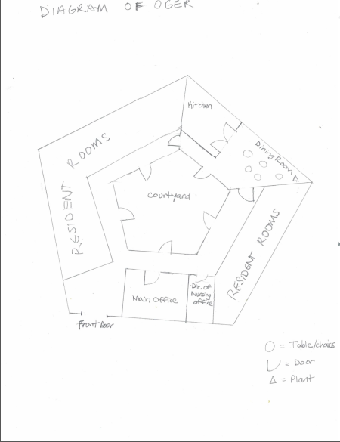

**EXHIBIT 1**

Oak Gardens Earth Residence agrees to purchase “Poochie,” a Maltipoo puppy, born March 3, 2019, for $1.00 from Aubrey Mills.

Seller Signature: Buyer Signature:

Aubrey Mills Aubrey Mills

**EXHIBIT 2**

**Job Description**

**Cook**

**Oak Gardens Earth Residence**

Oak Gardens Earth Residence is dedicated to the provision of quality health care and living accommodations for its residents. We believe that the foundation of Long Term Care is to serve our clients through a progressive nursing approach in a home-like setting, with the emphasis on individualized care.

**JOB RESPONSIBILITIES**

General responsibilities include but are not limited to:  
-follow menus and recipes set by Kitchen Manager  
-prepare all meals for residents  
-maintain kitchen cleanliness  
-read and follow diets and textures  
-fill in for Kitchen Manager when he/she is not at work  
-follow state guidelines and report any issues to Kitchen Manager or other supervisor  
-monitor and maintain temperature control, portion control

**QUALIFICATIONS**

1-2 years prior experience in food service.

Job Type: Full-time, hourly pay, $10 per hour.

Hours: 12:15-6:00 p.m., Every day but Monday, Tuesdays start at 6:00 p.m. and finish at 6:00 p.m. 30 minutes for lunch.

Experience:

* Dietary Cook: 1 year (Preferred)
* Cooking: 1 year (Preferred)

**EXHIBIT 3**

**Job Description**

**Kitchen Manager**

**Oak Gardens Earth Residence**

Oak Gardens Earth Residence is dedicated to the provision of quality health care and living accommodations for its residents. We believe that the foundation of Long Term Care is to serve our clients through a progressive nursing approach in a home-like setting, with the emphasis on individualized care.

**JOB RESPONSIBILITIES**

General responsibilities include but are not limited to:  
-establish menus and recipes  
-prepare all meals for residents when cook is not there  
-maintain kitchen cleanliness and manage kitchen  
-read and follow diets and textures   
-place orders for food and ingredient deliveries as needed  
-follow state guidelines and report any issues to Director of Nursing   
-monitor and maintain temperature control, portion control

**QUALIFICATIONS**

1-2 years prior experience in food service.

Job Type: Full-Time, salary

Hours: 6:00 a.m to 12:15, Every Day but Tuesday, Mondays work until 6:15 p.m., 30 minutes for lunch.

Experience:

* Dietary Cook: 1 year (Preferred)
* Cooking: 1 year (Preferred)
* Associate’s Degree or some post-high school business education (Preferred)



**EXHIBIT 4**



**EXHIBIT 5**

**EXHIBIT 6**

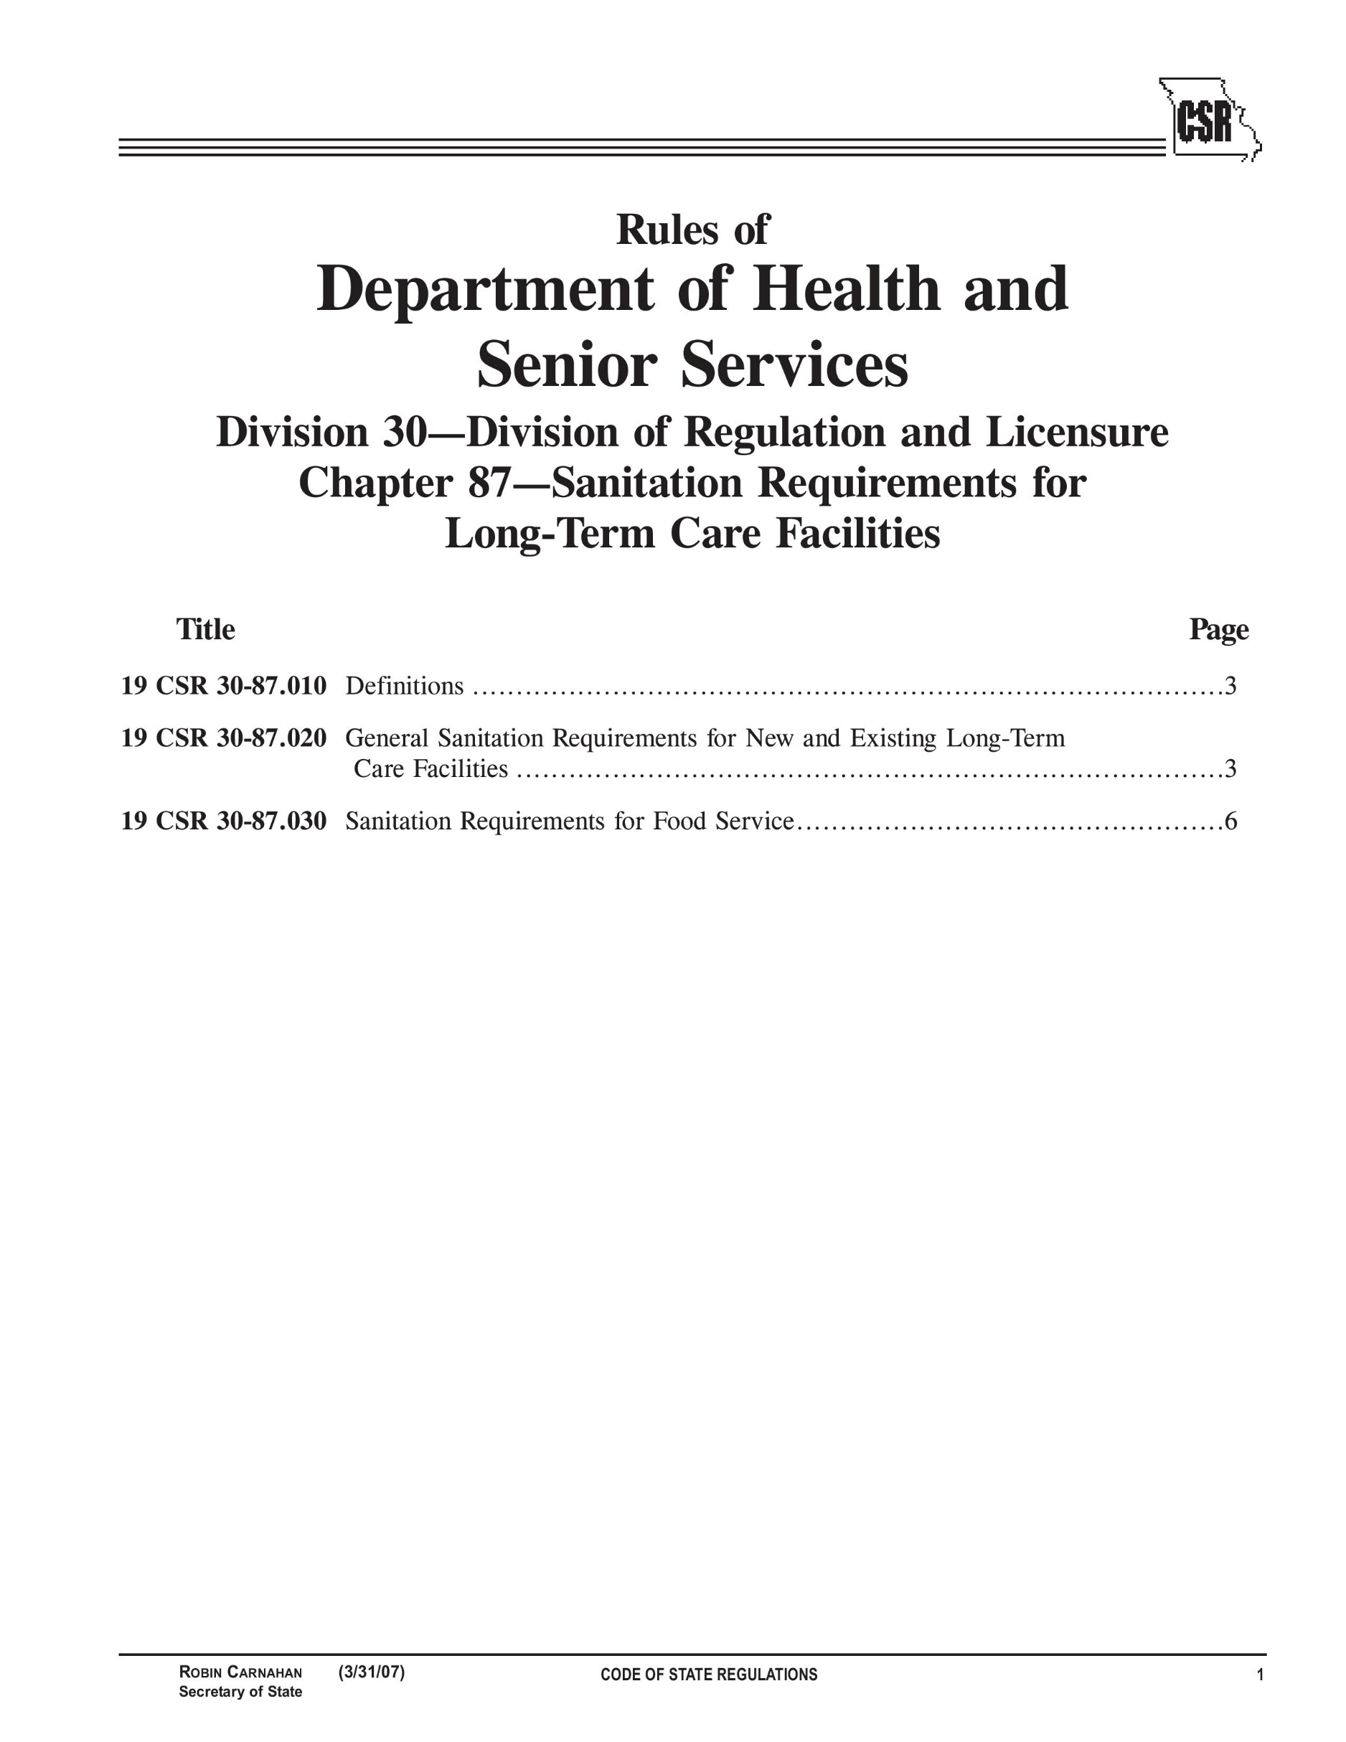

**EXHIBIT 7**

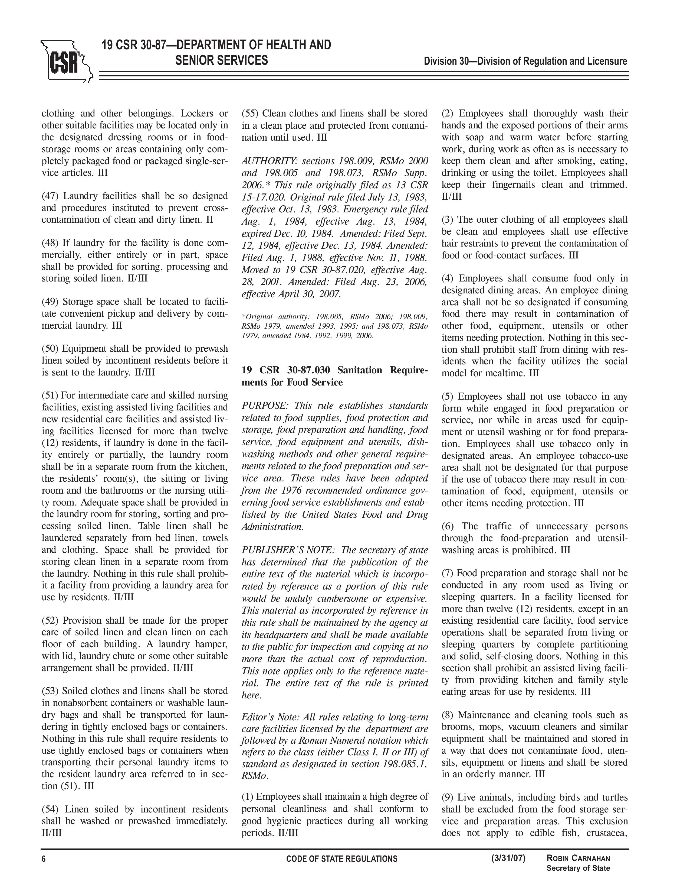

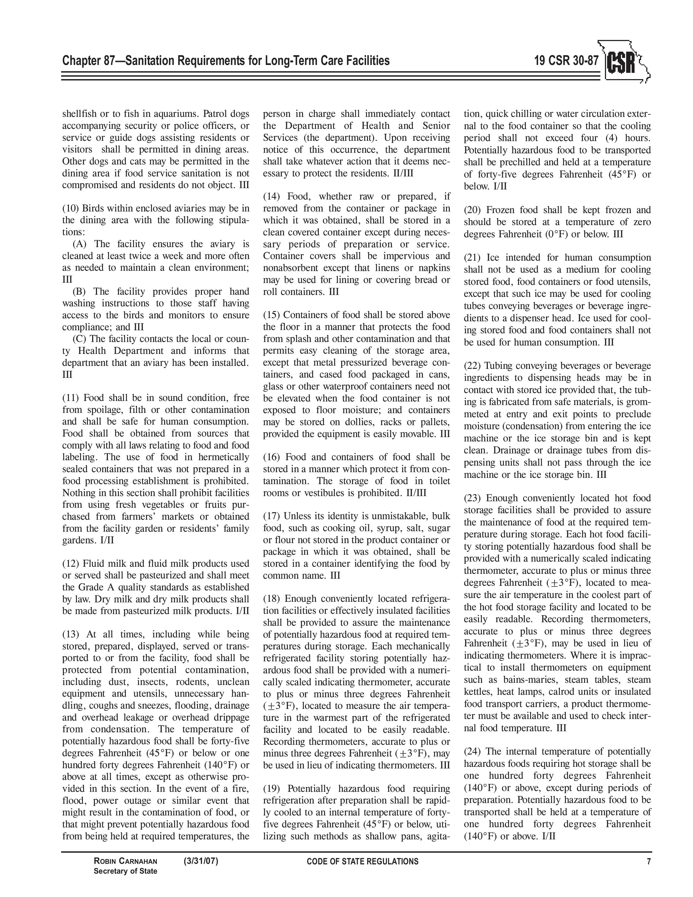

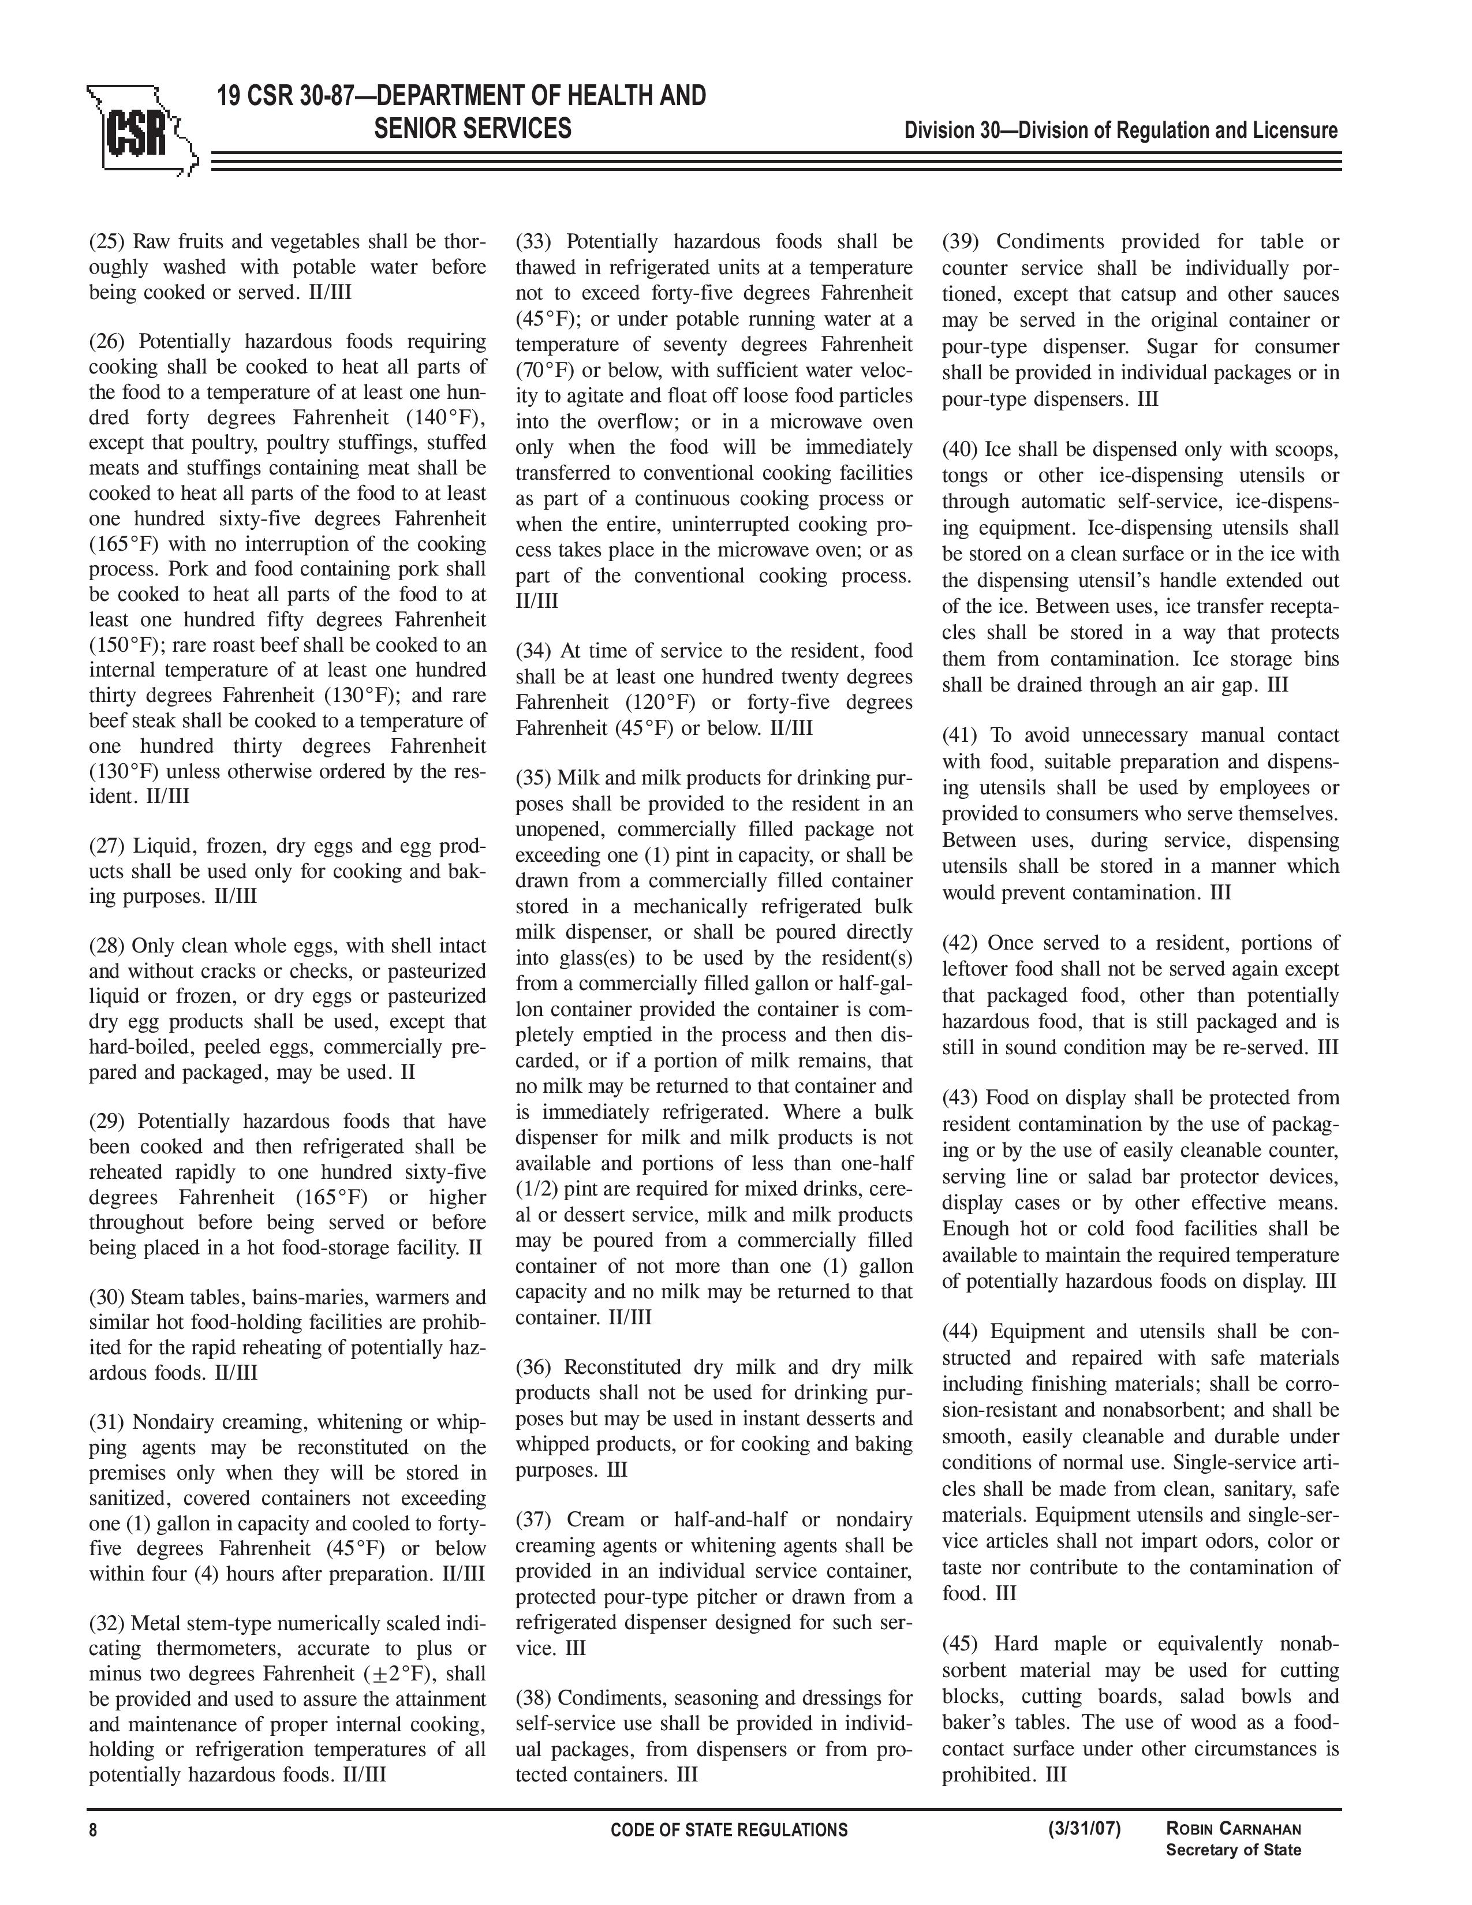

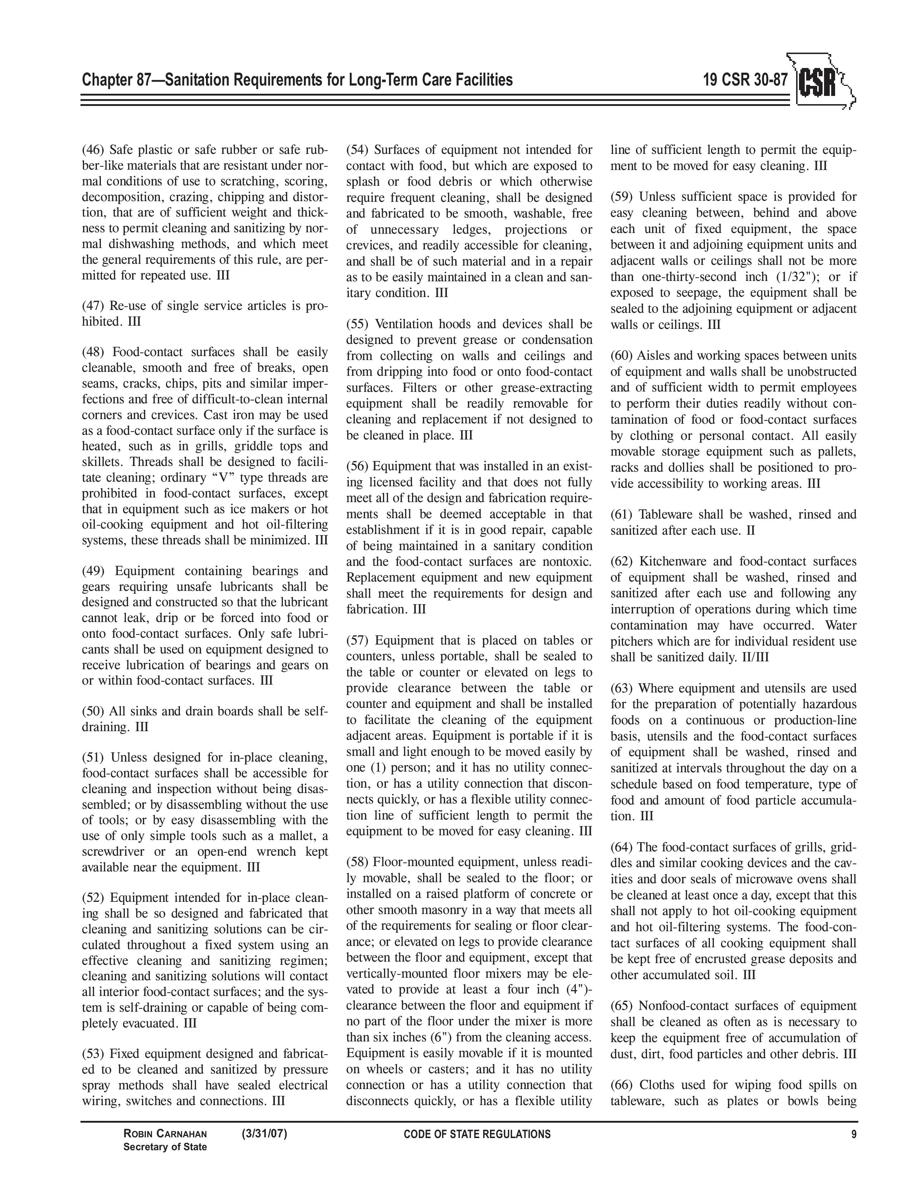

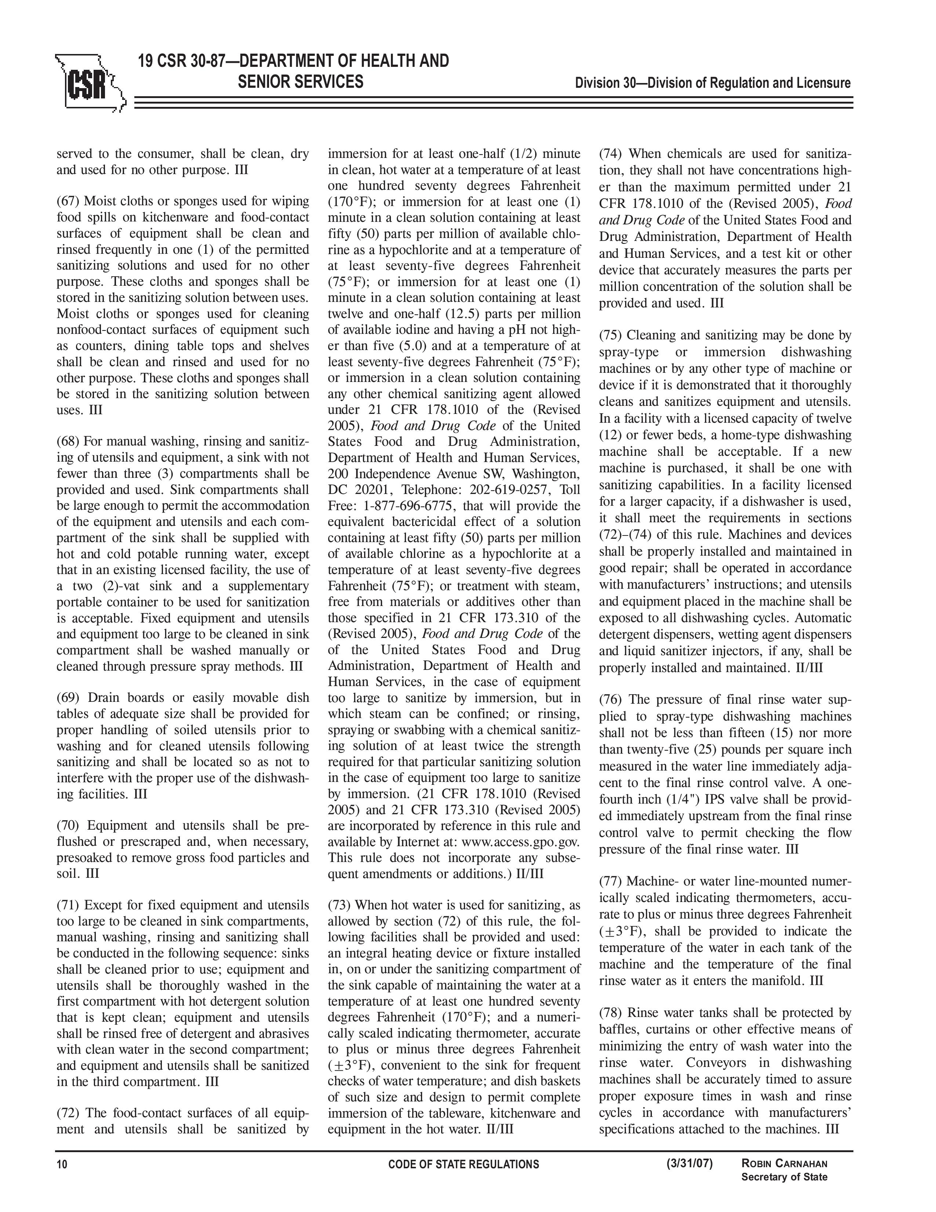

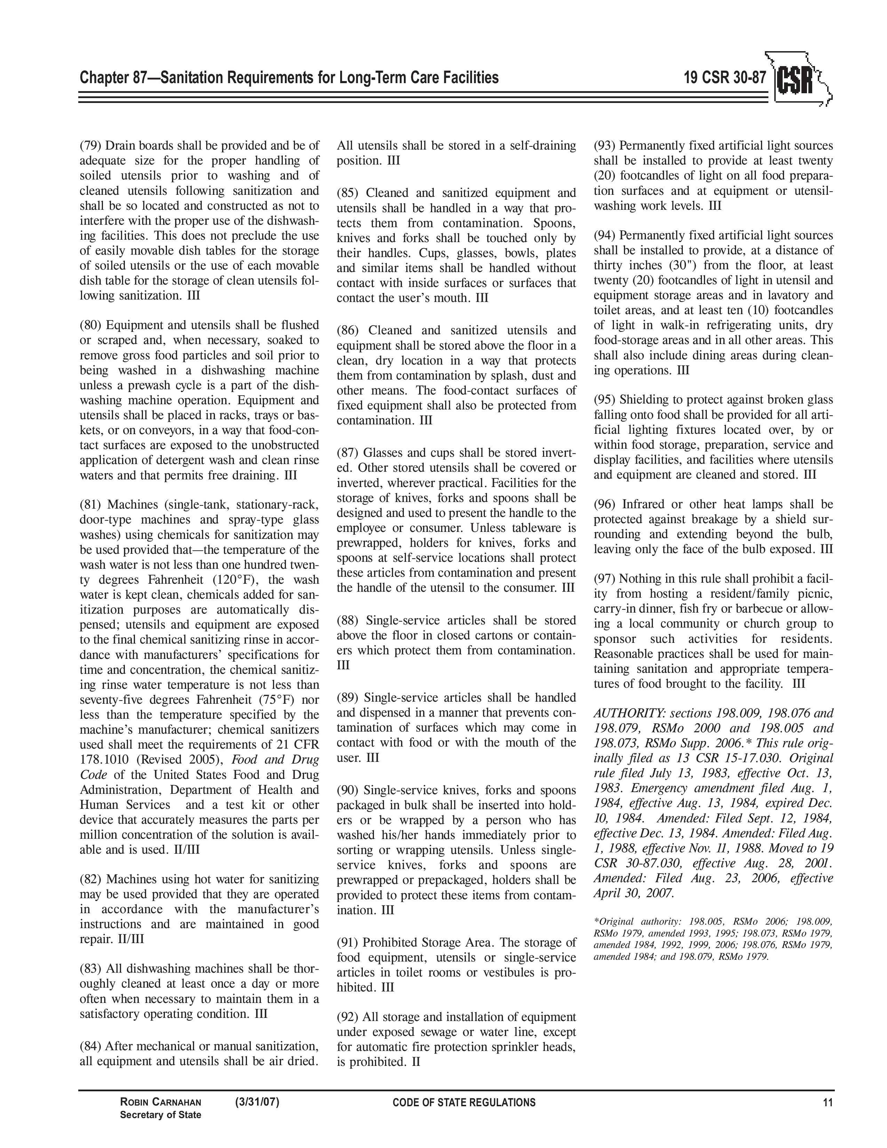



**EXHIBIT 8**



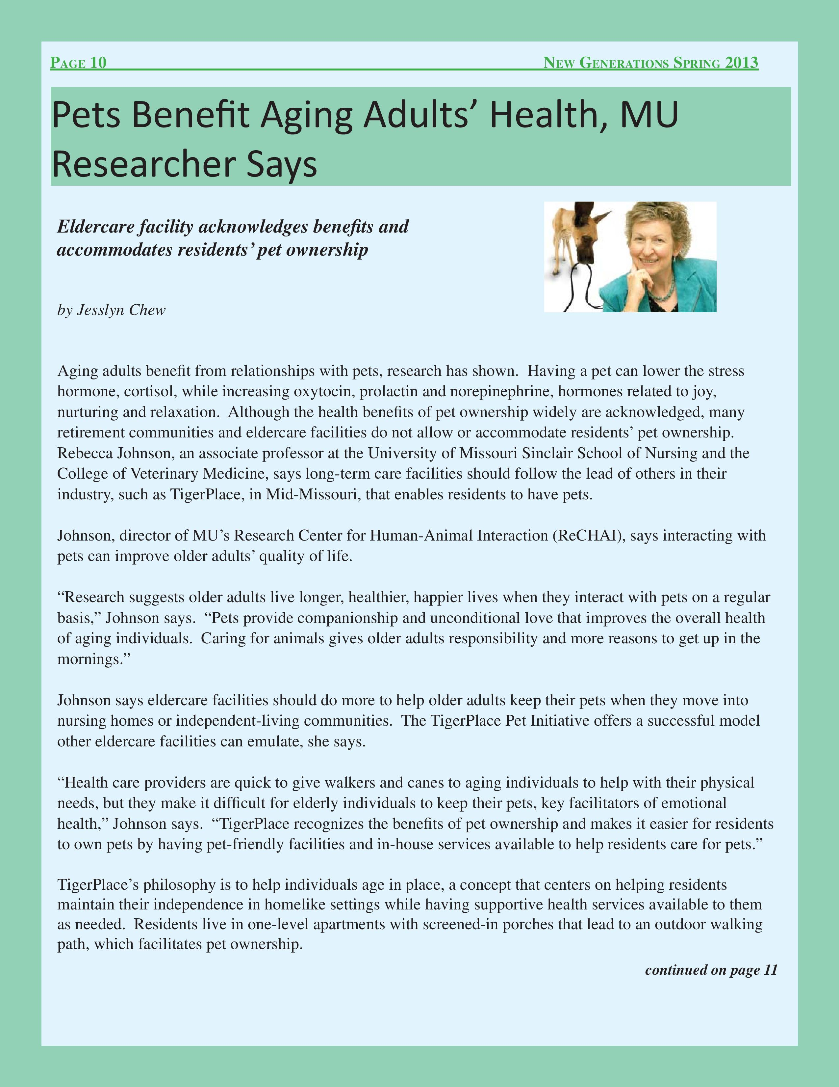



To: [fpelligrini@olivegardens.com](mailto:fpelligrini@olivegardens.com)

From: [amills@olivegardens.com](mailto:amills@olivegardens.com)

05/01/2014 5:34 pm

Hey there! I just wanted to bring to your attention that Roberta is saying that some of our docs are committing Medicare fraud by billing for services not rendered. Time for her to go bye-bye.

Let me know if you want me to take care of this first thing in the a.m.

Aubrey

**EXHIBIT 9**

Pre-Trial Motion No. 1

**IN THE CIRCUIT COURT OF SAINT LOUIS CITY**

**STATE OF MISSOURI**

|  |  |  |
| --- | --- | --- |
| CHRIS WHISTLER,  Plaintiff,  vs.  OAK GARDENS EARTH RESIDENCE,  Defendant. | )  )  )  )  )  )  ) ) ) | Civil Action No. 2019SMMT |
|  |  |  |
|  |  |  |

**PLAINTIFF’S MOTION TO STRIKE OR AMEND**

**JURY INSTRUCTION NUMBER 2(A)**

Plaintiff Chris Whistler requests an order from this Court striking Jury Instruction Number 2 because the instruction is not applicable to the instant case. Plaintiff was a cook and not a manager or supervisor. Thus, no jury will ever conclude that Defendant is entitled to the affirmative defense contained in Jury Instruction Number 2. The Missouri Whistleblower Protection Act (MWPA) does not define who is a supervisor or manager, but it is clear that supervisors and managers must have the authority to hire and fire other employees. Plaintiff did not have that authority.

WHEREFORE Plaintiff requests that Jury Instruction Number 2(a) be stricken.

CALL ME FIRST LAW FIRM

By: Call Me First

Call Me First

#1 Market Street

St. Louis, Missouri 63101

Telephone: (314) CAL-LNOW

Facsimile: (314) FACSNOW

CallMe@CallMeFirst.com

*Attorney for Plaintiff*

**285.575.**  **Citation of law — definitions — at-will employment doctrine codified — protected persons, prohibited discharge — action for damages, when, remedies. —**1.  This section shall be known and may be cited as the “Whistleblower’s Protection Act”.

  2.  As used in this section, the following terms shall mean:

  (1)  **“Because”** or **“because of”**, as it relates to the adverse decision or action, the person’s status as a protected person was the motivating factor;

  (2)  **“Employer”**, an entity that has six or more employees for each working day in each of twenty or more calendar weeks in the current or preceding calendar year.  “Employer” shall not include the state of Missouri or its agencies, instrumentalities, or political subdivisions, including but not limited to any public institution of higher education, a corporation wholly owned by the state of Missouri, an individual employed by an employer, or corporations and associations owned or operated by religious or sectarian organizations;

  (3)  **“Proper authorities”**, a governmental or law enforcement agency, an officer of an employee’s employer, the employee’s supervisor employed by the employer, or the employee’s human resources representative employed by the employer;

  (4)  **“Protected person”**, an employee of an employer who has reported to the proper authorities an unlawful act of his or her employer; an employee of an employer who reports to his or her employer serious misconduct of the employer that violates a clear mandate of public policy as articulated in a constitutional provision, statute, or regulation promulgated under statute; or an employee of an employer who has refused to carry out a directive issued by his or her employer that if completed would be a violation of the law.  An employee of an employer is not a protected person if:

  (a)  The employee is a supervisory, managerial, or executive employee or an officer of his or her employer and the unlawful act or serious misconduct reported concerns matters upon which the employee is employed to report or provide professional opinion; or

  (b)  The proper authority or person to whom the employee makes his or her report is the person whom the employee claims to have committed the unlawful act or violation of a clear mandate of public policy;

  (5)  **“The motivating factor”**, the employee’s protected classification actually played a role in the adverse decision or action and had a determinative influence on the adverse decision or action.

  3.  This section is intended to codify the existing common law exceptions to the at-will employment doctrine and to limit their future expansion by the courts.  This section, in addition to [chapter 213](http://revisor.mo.gov/main/OneChapter.aspx?chapter=213) and [chapter 287](http://revisor.mo.gov/main/OneChapter.aspx?chapter=287), shall provide the exclusive remedy for any and all claims of unlawful employment practices.

  4.  It shall be an unlawful employment practice for an employer to discharge an individual defined as a protected person in this section because of that person’s status as a protected person.

  5.  A protected person aggrieved by a violation of this section shall have a private right of action for actual damages for violations of this section but not for punitive damages.  However, if a private right of action for damages exists under another statutory or regulatory scheme, whether under state or federal law, no private right of action shall exist under this statute.

  6.  Any party to any action initiated under this section may demand a trial by jury.

  7.  A protected person aggrieved by a violation of this section shall have a private right of action that may be filed in a court of competent jurisdiction.  The only remedies available in such an action shall be:

  (1)  Back pay;

  (2)  Reimbursement of medical bills directly related to a violation of this section; and

  (3)  Additionally, if a protected person proves, by clear and convincing evidence, that the conduct of the employer was outrageous because of the employer’s evil motive or reckless indifference to the rights of others, then, such person may receive double the amount awarded under subdivisions (1) and (2) of this subsection, as liquidated damages.  In applying this subdivision, the provisions of section [510.263](http://revisor.mo.gov/main/OneSection.aspx?section=510.263) shall be applied as though liquidated damages were punitive damages and as though the amounts referenced in subdivisions (1) and (2) of this subsection were compensatory damages.

  8.  The court, in addition to the damages set forth in subsection 7 of this section, may award the prevailing party court costs and reasonable attorney fees; except that a prevailing respondent may be awarded reasonable attorney fees only upon a showing that the case was without foundation.

--------

(L. 2017 S.B. 43)

Excerpts taken from:

Supreme Court of Missouri, Division No. 2.

STATE

v.

HEMENOVER.

May 16, 1905.



GANTT, J.

This is a prosecution by information, filed by the assistant prosecuting attorney of the St. Louis court of criminal correction, charging the defendant, as manager of the Banner Rubber Company, with having on the 19th of January, 1904, in the city of St. Louis, willfully and unlawfully suffered to be emitted and discharged from the smokestack or chimney of a certain building belonging to said Banner Rubber Company, and situated at the corner of Bittner and Kendrick streets in said city and within the corporate limits of said city, dense  smoke into the open air, in violation of “An act to prohibit the discharge into the open air of dense smoke,” approved March 21, 1901 (Laws 1901, p. 73).

The defendant contends that, as he was charged as a manager of said corporation, there was no proof that he bore that relation to the said company, and therefore he was entitled to acquittal. Asked what connection Mr. Hemenover had with that company, he stated that no one had the exclusive charge of the place; that Mr. Hemenover had charge of some of the departments. He was asked what was the character of the work he did there, and answered: “Well, I help do a good many things. I do some of the buying, and others do some of it, and I look after the manufacturing department.” “Q. What supervision, if any, do you exercise over the engine room? A. About the same as I do over the other departments.” On cross–examination he was asked: “You are the president of the factory, are you not? A. A corporation has no such office. Q. Aren't you known as the president? A. By courtesy; yes, sir. Q. You knew the firemen were green? A. Well, only from my observation. I had observed their work.” Considering, then, the evidence before us, was there or not sufficient evidence to justify the finding of the court that the defendant was a manager of said corporation within the meaning and spirit of the act? According to the defendant's own evidence, he was the secretary, purchasing agent, and had charge of the manufacturing department of that company. The further evidence shows that he exercised supervision over the engine room in which the dense smoke was generated. The evidence further shows that he was regarded by the other employés and officers of the company as a de facto president. The term “manager” is defined in 19 Am. & Eng. Enc. of Law, 707, as “a person appointed or elected to manage the affairs of another. The term is applied to those officers of a corporation who are authorized to manage its affairs.” The effort of the defendant in this case was to show that he was not the exclusive manager of the said plant, but it does not follow that, because other officers also manage said plant, the defendant, who was a director and secretary of the company, and who, according to his own evidence, had charge of the manufacturing and control of other departments except the office room, was not thereby a manager within the meaning of the act. If so, then all that the company would have to do to escape responsibility for the violation of this act would be to decline to name any one person as manager, and then all the directors and officers would be exempt, though they jointly manage the plant. We think there was evidence from which the court was justified in finding that the defendant was the principal manager, at least of this establishment, and that he acted as such.

The question, therefore, is whether a person who is thus manager de son tort—manager in his own wrong—whether he can protect himself from the liability cast upon a manager under section 27 by saying, ‘I am not manager de jure.’ I think he cannot. Our conclusion is that the demurrer to the evidence was properly overruled, and that the conviction must stand, and it is accordingly so ordered.

BURGESS, P. J., absent. FOX, J., concurs.



Excerpts taken from:

Missouri Court of Appeals,

Western District.

CENTRAL COUNTY EMERGENCY 911, Appellant,

v.

INTERNATIONAL ASSOCIATION OF FIREFIGHTERS LOCAL 2665, Respondent.

No. WD 54519.

April 28, 1998.



[ULRICH](https://1.next.westlaw.com/Link/Document/FullText?findType=h&pubNum=176284&cite=0236263801&originatingDoc=I423f2fb3e7be11d99439b076ef9ec4de&refType=RQ&originationContext=document&transitionType=DocumentItem&contextData=(sc.Search)&analyticGuid=I423f2fb3e7be11d99439b076ef9ec4de), Chief Judge, Presiding Judge.

Central County Emergency 911 (“Central”), a fire and emergency dispatching center, appeals the decision of the circuit court affirming the decision of the State Board of Mediation (“Board”) finding that shift supervisors were not “supervisory employees” and affiliated with management and, therefore, were appropriately included in the International Association of Fire Fighters, Local 2655 (“IAFF”) bargaining unit with the dispatchers. The decision of the State Board of Mediation is affirmed.

**II. THE SHIFT SUPERVISORS ARE NOT SUPERVISORY EMPLOYEES**

As its second point on appeal, Central argues that the Board's conclusion that shift supervisors are not supervisory employees is unsupported by competent and substantial evidence.

Supervisors are generally defined as those employees who formulate, determine or effectuate policies on behalf of their employer. [*Baer v. Civilian Personnel Div.,* 747 S.W.2d 159, 163 (Mo.App.1988)](https://1.next.westlaw.com/Link/Document/FullText?findType=Y&serNum=1988004975&pubNum=0000713&originatingDoc=I423f2fb3e7be11d99439b076ef9ec4de&refType=RP&fi=co_pp_sp_713_163&originationContext=document&transitionType=DocumentItem&contextData=(sc.Search)#co_pp_sp_713_163). To determine the supervisory status of employees, the Board has set forth seven factors:

(1) The authority to effectively recommend the hiring, promotion, transfer, discipline or discharge of employees; (2) the authority to direct and assign the work force; (3) the number of employees supervised and the number of other persons exercising greater, similar, or lesser authority with respect to the same employees; (4) the level of pay, including an evaluation of whether the supervisor is paid for his skill or for his supervision of employees; (5) whether the supervisor is primarily supervising an activity or is primarily supervising employees; (6) whether the supervisor is a working supervisor or whether he spends a substantial majority of his time supervising employees; (7) the amount of independent judgment and discretion exercised in the supervision of employees.

*Id.*

Central first argues that the Board was bound by the statutory definition of supervisors contained in the National Labor Relations Act. The N.L.R.B. test for determining supervisory status is set forth at [Title 29, section 152(11) of the United States Code](https://1.next.westlaw.com/Link/Document/FullText?findType=L&pubNum=1000546&cite=29USCAS152&originatingDoc=I423f2fb3e7be11d99439b076ef9ec4de&refType=RB&originationContext=document&transitionType=DocumentItem&contextData=(sc.Search)#co_pp_9da60000c3824). [29 U.S.C. § 152(11) (1994)](https://1.next.westlaw.com/Link/Document/FullText?findType=L&pubNum=1000546&cite=29USCAS152&originatingDoc=I423f2fb3e7be11d99439b076ef9ec4de&refType=RB&originationContext=document&transitionType=DocumentItem&contextData=(sc.Search)#co_pp_9da60000c3824). [Section 152(11)](https://1.next.westlaw.com/Link/Document/FullText?findType=L&pubNum=1000546&cite=29USCAS152&originatingDoc=I423f2fb3e7be11d99439b076ef9ec4de&refType=RB&originationContext=document&transitionType=DocumentItem&contextData=(sc.Search)#co_pp_9da60000c3824) **defines** a **supervisor** as one:

having authority in the interest of the employer, to hire, transfer suspend, layoff, recall, promote, discharge, assign, reward, or discipline other employees or responsibility to direct them, or to adjust their grievances or effectively to recommend such action, if in connection with the foregoing the exercise of such authority is not of a merely routine or clerical nature, but requires the use of independent judgment.

*Id.*

The decision of the State Board of Mediation is affirmed.

All concur.

NATIONAL LABOR RELATIONS ACT  
Also cited NLRA or the Act; 29 U.S.C. §§ 151-169  
[Title 29, Chapter 7, Subchapter II, United States Code]

DEFINITIONS

 Sec. 2. [§152.] When used in this Act [subchapter]--

 (1) The term "person" includes one or more individuals, labor organizations, partnerships, associations, corporations, legal representatives, trustees, trustees in cases under title 11 of the United States Code [under title 11], or receivers.

. . .

 (11) The term "supervisor" means any individual having authority, in the interest of the employer, to hire, transfer, suspend, lay off, recall, promote, discharge, assign, reward, or discipline other employees, or responsibly to direct them, or to adjust their grievances, or effectively to recommend such action, if in connection with the foregoing the exercise of such authority is not of a merely routine or clerical nature, but requires the use of independent judgment.

Pre-Trial Motion No. 2

**IN THE CIRCUIT COURT OF SAINT LOUIS CITY**

**STATE OF MISSOURI**

|  |  |  |
| --- | --- | --- |
| CHRIS WHISTLER,  Plaintiff,  vs.  OAK GARDENS EARTH RESIDENCE,  Defendant. | )  )  )  )  )  )  ) ) ) | Civil Action No. 2019SMMT |
|  |  |  |
|  |  |  |

**DEFENDANT’S MOTION IN LIMINE TO EXCLUDE TESTIMONY OF FRANCIS/FRANCES PELLEGRINI REGARDING PRIOR ALLEGATIONS OF WRONGFUL DISCHARGE AGAINST AUBREY MILLS**

Defendant Oak Gardens Earth Residence seeks an order, in limine, to exclude evidence of other, prior complaints by employees of wrongful discharge against Aubrey Mills or her prior employers for engaging in whistleblowing. The testimony of Mr./Ms. Pellegrini does not establish a sufficient similarity in circumstances to be probative of Aubrey Mills’ motivation for discharging Plaintiff in this case.

WHEREFORE, Defendant requests an order from this Court excluding testimony relating to prior complaints of wrongful discharge involving Aubrey Mills.

HELP IS ON THE WAY LAW FIRM

By: Help Today

HELP TODAY

#2 Market Street

St. Louis, Missouri 63101

Telephone: (314) ASK-HELP

Facsimile: (314) FAX-HELP

HelpOnWay@helponway.com

*Attorney for Defendant*

Excerpts taken from:

United States Court of Appeals,Eighth Circuit.

Michael E. McPHEETERS, Appellant, v. BLACK & VEATCH CORPORATION, Appellee.

No. 04-2268.

Decided: November 04, 2005

Before WOLLMAN, HANSEN, and BENTON, Circuit Judges. Gene P. Graham, Jr., argued, Independence, MO (Deborah J. Blakely, on the brief), for appellant. Thomas R. Buchanan, argued, Kansas City, MO (Linda C. McFee, on the brief), for appellee.

Michael E. McPheeters filed this lawsuit against his former employer, Black & Veatch Corporation, alleging age discrimination in violation of the Age Discrimination in Employment Act, 29 U.S.C. § 621-634 (2000), and the Missouri Human Rights Act, Mo. Rev. Stats. § 213.010-.137 (2000).   Mr. McPheeters now appeals the judgment entered by the district court [1](https://caselaw.findlaw.com/us-8th-circuit/1148662.html" \l "footnote_1) following a jury verdict in favor of Black & Veatch.   After carefully reviewing the record, we affirm.

I.

Mr. McPheeters presented evidence at trial that he was fired after working 28 years for Black & Veatch Corporation, an engineering/construction firm in Kansas City, Missouri, that specializes in large, coal-fired power plants and municipal water and wastewater plants.   In 1988, he was promoted to Director of Photography, a division within the Corporate Communications Department.   In the 1990s, he supervised a staff of two other photographers until the two staffers were fired in 1996 in an effort to cut company costs.   Mr. McPheeters worked long hours and traveled all around the world to complete his photographic assignments.   By all accounts, his photography work was outstanding.   Nevertheless, Black & Veatch terminated his employment in 2001, when Mr. McPheeters was 54 years old, after several cost-benefit studies recommended outsourcing the photography work.

Mr. McPheeters attempted to prove that he was fired on the basis of age discrimination.   He presented evidence that in August 2000, William Cole, Vice President of Corporate Development, allegedly instructed Laura Luckert, Director of Creative Resources in the Corporate Communications Department and Mr. McPheeters' supervisor at the time, to try to eliminate the “gray hairs” in her department.   Specifically, Luckert testified that Cole told her, “You've got a lot of gray hairs in your department, and I think we could save some money in that area.   I'd like you to do a cost-analysis on those folks.”   (Trial Tr. at 329.)   She said she was offended by the comment, and when she asked what he meant by “gray hairs,” Cole named Bruce Erickson, a videographer, as an example.  “He's been there a long time.   He's older.   He's at the top of his pay scale․ I think we could get what he does for us cheaper.”  (Trial Tr. at 335.)   Luckert said that Cole told her to check into outsourcing the work and also asked her to work on drawing up a freelance photography contract to “see if we can get Mike McPheeters off the payroll.”  (Trial Tr. at 337.)   Luckert testified that she was shocked and offended by the alleged “gray hairs” comment and said that she immediately determined to leave Black & Veatch.   Luckert voluntarily ended her employment with Black & Veatch on November 2, 2000.

[omitted factual background]

Following the trial, the jury entered a verdict in favor of Black and Veatch.   On appeal, Mr. McPheeters challenges several rulings made by the district court both before and during trial.

II.

A. Pretrial Rulings.

Prior to trial, Mr. McPheeters' attorney sought a ruling on the admissibility of . . .every complaint of age discrimination brought against Black & Veatch from 1998 through the present, and Plaintiff's Exhibit 4, an Excel spreadsheet created by Retzke, listing all complaints of discrimination against the company from 1999 through 2002.   Mr. McPheeters argues that the district court erred by excluding this evidence, but the district court did not order a blanket exclusion of this evidence.

 We . . .find no abuse of discretion in the district court's pretrial ruling concerning the Excel spreadsheet and Interrogatory No. 7, which listed other complaints of discrimination in the workplace.   Consistent with our opinion in Callanan v. Runyun, 75 F.3d 1293, 1297-98 (8th Cir.1996), the district court cautiously refused to order a blanket exclusion of this evidence.   The court concluded that on the pretrial record, these documents were overly broad and not specifically relevant to Mr. McPheeters' claim of discrimination.   While background evidence of an employer's discriminatory policies or practices “may be critical for the jury's assessment of whether a given employer was more likely than not to have acted from an unlawful motive,” Estes v. Dick Smith Ford, Inc., 856 F.2d 1097, 1103 (8th Cir.1988), overruled in part on other grounds by Price Waterhouse v. Hopkins, 490 U.S. 228, 109 S.Ct. 1775, 104 L.Ed.2d 268 (1989), as recognized in Foster v. Univ. of Ark., 938 F.2d 111, 115-16 (8th Cir.1991), the evidence must nevertheless “assist in the development of a reasonable inference of discrimination within the context of each case's respective facts,” Callanan, 75 F.3d at 1298 (internal quotations omitted).   The district court specifically left open the possibility that the plaintiff at some point in the trial could make a more specific record showing the relevance of these other complaints of discrimination, but indicated that such a record did not yet exist at the pretrial stage.

 We see no abuse of discretion.   The evidence of other complaints as listed in these documents did not reveal that any particular discriminatory policy or practice was prevalent at Black & Veatch.   No witnesses were prepared to testify to any specific factual allegations of other discrimination.   Additionally, neither the spreadsheet nor the interrogatory answer indicated what decisionmakers or departments were involved in those complaints, and thus, the other complaints were not shown to bear a connection to the employees allegedly involved in discriminating against Mr. McPheeters.   See id.   We cannot say that the district court abused its discretion as it “was in a unique position to adjudge the relevance and probative value of the testimony.”   Id. The plaintiff made no further offer of proof regarding this evidence or any of the specific claims listed.

Accordingly, we affirm the judgment of the district court.

HANSEN, Circuit Judge.

Excerpts taken from:

Missouri Court of Appeals,Western District.

G. Steven COX, Appellant, v. KANSAS CITY CHIEFS FOOTBALL CLUB, INC., Respondent.

No. WD 76616.

Decided: August 05, 2014

Before Division Four: ALOK AHUJA, Chief Judge, Presiding, CYNTHIA L. MARTIN, Judge and WAYNE P. STROTHMANN, Special Judge. Chad C. Beaver and Lewis M. Galloway, Kansas City, MO, for appellant. Anthony J. Romano, Alison P. Lungstrum and Eric E. Packel, Kansas City, MO, for respondent.

G. Steven Cox (“Cox”) appeals a judgment in favor of the Kansas City Chiefs Football Club (“Chiefs”) entered following a jury verdict in an age discrimination suit. Cox claims the trial court abused its discretion in the exclusion of certain evidence at trial, and committed plain error in failing to intervene during the Chiefs' closing argument. Finding no error, we affirm the trial court's judgment.

Cox was hired in 1998 by the Chiefs as a maintenance manager.

[facts omitted]

Cox was terminated . . . on October 14, 2010. Cox was told that he was being terminated for poor performance, and was given examples, including the unauthorized Crowley pay raise. Cox later told another Chiefs' employee, Brenda Sniezek, that he had been terminated because he gave Crowley a raise in violation of Donovan's instructions. At the time of his termination, Cox was 61 years old. His position was later filled by a 37–year old.

Cox filed a Charge of Discrimination with the Missouri Commission on Human Rights (“MCHR”). In the Charge, Cox stated that the Chiefs told him he had been fired for performance reasons, including the Crowley pay raise. Cox alleged in his Charge a single, discrete act of age discrimination on the day of his termination. When Cox filed suit following issuance of a right to sue letter, his petition similarly alleged a single, discrete act of age discrimination on the date of his termination.

Cox's case was tried to a jury. After a 14–day trial, the jury returned a verdict in favor of the Chiefs on Cox's claim of age discrimination. Cox appeals.

Point One

In his first point on appeal, Cox claims that the trial court abused its discretion “in ordering a blanket exclusion of testimony and evidence from and about 17 or more former employees.” Cox claims that the excluded evidence was “related to [the Chiefs'] systematic elimination of older front office employees.” Cox claims the excluded evidence was “highly relevant” because “it would have demonstrated [the Chiefs'] discrimination against other front office employees on the basis of their age,” and “would have demonstrated [the Chiefs'] discriminatory motives and/or intent.” Cox thus sought to offer evidence about the termination of 17 other employees for two distinct reasons: (i) to establish a pattern and practice by the Chiefs' on the business side of its operations of discriminating against older employees; and (ii) as circumstantial evidence permitting an inference that the stated reason for terminating Cox was pre-textual.

(ii) The Trial Court's Exclusion of Testimony From and About 17 Former Chiefs' Employees and Cox's Related Offers of Proof

The Chiefs sought an in limine ruling to exclude testimony from or about 17 former employees of the Chiefs[2](https://caselaw.findlaw.com/mo-court-of-appeals/1674673.html" \l "footnote_2) whom the Chiefs anticipated Cox would call to testify about the circumstances of their departures from employment. The Chiefs argued that these former employees were not sufficiently similarly situated to Cox's circumstances to be probative of his discrete claim of discriminatory termination, and that the evidence could not be separately offered to establish a pattern or practice of discrimination because Cox did not allege this form of discrimination in his MCHR Charge or in his petition. The Chiefs thus argued that the evidence was irrelevant and unduly prejudicial. On February 8, 2013, the trial court granted the Chiefs' in limine motion without explanation.

. . .

Generally, it is true that “ ‘evidence of other acts of [a] defendant are admissible if those acts are sufficiently connected with the wrongful acts that they may tend to show defendant's disposition, intention, or motive in the commission of the acts for which ․ damages are claimed.’ “ Kline v. City of Kansas City, 334 S.W.3d 632, 643 (Mo.App.2011) (quoting Brockman v. Regency Fin. Corp., 124 S.W.3d 43, 51 (Mo.App.W.D.2004) (emphasis in original)). “In determining whether [such] evidence is admissible in a discrimination case, the trial court must ascertain whether the proffered evidence would allow ‘a rational finder of fact to infer a discriminatory motive or ․ [to] conclude that the employer intended to discriminate in reaching the decision at issue.’ “ Id. (quoting West v. Conopco Corp., 974 S.W.2d 554, 556 (Mo.App.W.D.1998)).

Here, Cox hoped to have 17 former employees testify about the circumstances of each employee's departure from employment with the Chiefs for the purpose of circumstantially establishing that the Chiefs possessed a discriminatory motive or intent in terminating Cox. “There is no blanket exclusion in discrimination cases of [such “me too”] evidence․ Rather, the relevancy of such evidence must be reviewed on a case-by-case basis.” Hurst v. Kansas City, Missouri School Dist., No. WD76534, 2014 WL 1677822, at \* 11 (Mo.App. W.D. April 29, 2014). Though “me too” evidence cannot be summarily excluded, “me too” evidence from or about other employees is not logically relevant to tend to prove discriminatory intent or pretext unless it is established that the circumstances of the plaintiff and the other employees are “sufficiently similar,” a relationship which the plaintiff bears the burden of establishing. Williams v. Trans States Airlines, Inc., 281 S.W.3d 854, 874 (Mo.App.E.D.2009).

First, though Cox correctly observes that the admissibility of “me too” evidence must be assessed on a case-by-case basis, Cox's Brief curiously fails to address the circumstances of the 17 former employees on a case-by-case basis.

Moreover, even were we to conclude (which we do not) that the trial court abused its discretion [in refusing to admit the evidence] Cox would still be required to establish that the trial court abused its discretion in alternatively ruling that the offers of proof were not legally relevant. “Legal relevance involves a process through which the probative value of the evidence (its usefulness) is weighed against the dangers of unfair prejudice, confusion of the issues, misleading the jury, undue delay, waste of time or needless presentation of cumulative evidence.” Porter v. Toys ‘R’ Us–Deleware, Inc., 152 S.W.3d 310, 318 (Mo.App.W.D.2004) (citations omitted). A trial court must weigh the probative value of evidence against any possible prejudice which might occur due to its admission because “[l]ogically relevant evidence is not necessarily admissible; the evidence must also be legally relevant.” Id. Here, the trial court held that “any probative value of the testimony proposed by the plaintiff from these witnesses would be outweighed by the prejudicial effect it would have upon the jury ․ I believe the testimony of these other past employees would only serve to confuse and distract the jury.”[19](https://caselaw.findlaw.com/mo-court-of-appeals/1674673.html" \l "footnote_19)  Point one is denied.[20](https://caselaw.findlaw.com/mo-court-of-appeals/1674673.html" \l "footnote_20)

The trial court's judgment is affirmed.

CYNTHIA L. MARTIN, Judge.

All concur.